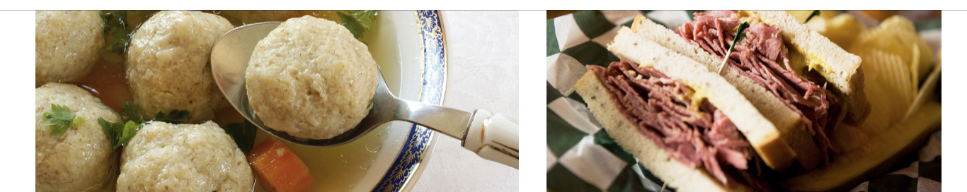
Welcome Summer with a Delicious Jewish Food Order!
A Jewish Food Festival To Go, Sunday, May 31, 2026
Order Deadline: Thursday, May 28, 2026
EZ Order & pay online: www.bnaiabraham.net/donations/
Click on donate and choose fund raiser from the drop down menu.
Please specify your order in the comments when making a PayPal donation
For example: “1 corned beef box”, or “2 matzah ball soups”, etc.
Name: ___________________________________________________
Phone #: _________________________________________________
Email: ___________________________________________________
Address: _________________________________________________
_________________________________________________________
Choose a Nosh Box—$25. Featuring our famous deli sandwiches on rye (corned beef, pastrami, turkey, tongue), mustard, pickles, cole slaw, apple sauce spice cake
Qty.____corned beef nosh box @$25 ea. $______
Qty.____pastrami nosh box @$25 ea. $______
Qty.____turkey nosh box @$25 ea. $______
Qty.____tongue nosh box @$25 ea. $______
Qty.____ MATZAH BALL SOUP @$10 ea. $________
Qty.____ VEGETARIAN CABBAGE SOUP @ $10 ea. $________
ORDER TOTAL $__________
Orders will be picked up at 53 E. Baltimore Street Between 11:30-2:30
Drive through the parking lot to the pick up station.

If you send in a hardcopy order, payment may also be made online:

Or mail your order and check to “Congregation B’nai Abraham” to
M. Armel, 384 Key Circle, Hagerstown, MD 21740.

