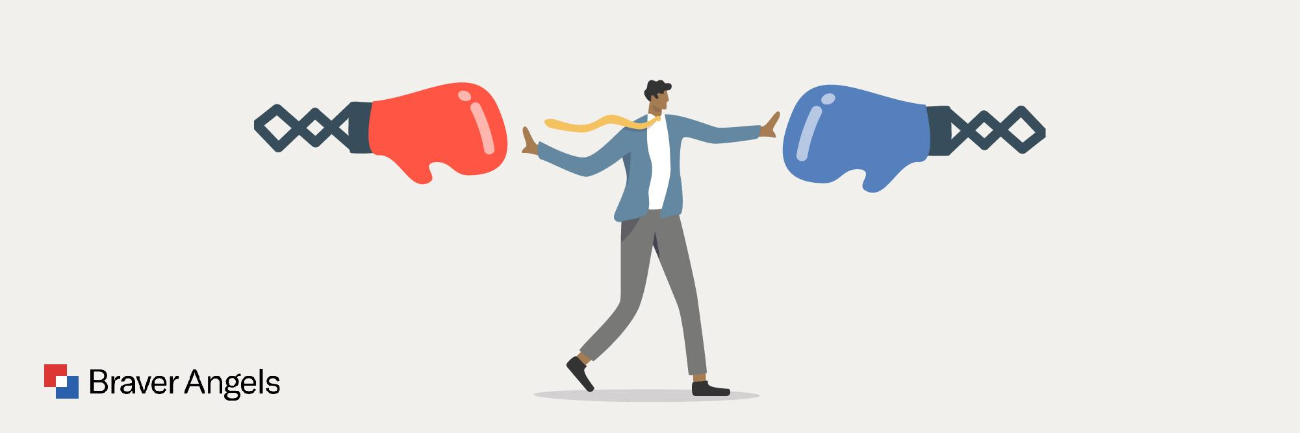

Skills for Disagreeing Better
Saturday July 18, 2026
Time: 1:30 PM – 3:00 PM | Location: Middletown Library, 31 East Green St., Middletown, MD

Summary

The Skills for Disagreeing Better workshop helps participants understand the values and concerns of those who differ from them politically and teaches essential skills for communicating across differences and finding common ground.

Goals

- Grow understanding of the values and concerns of people who differ from you politically
- Learn skills for listening in a way the other person feels heard
- Learn skills for sharing viewpoints in a way the other person might hear even if they disagree

Who Can Attend

This workshop is open to everyone.

What to Expect

You will learn about the values and concerns of the other political side and practice skills for communicating more effectively in the presence of disagreement.
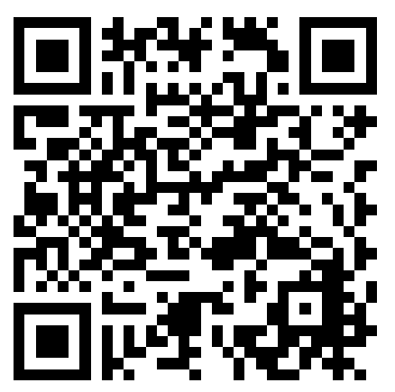 Scan to Register

