Riley House Senior Recital
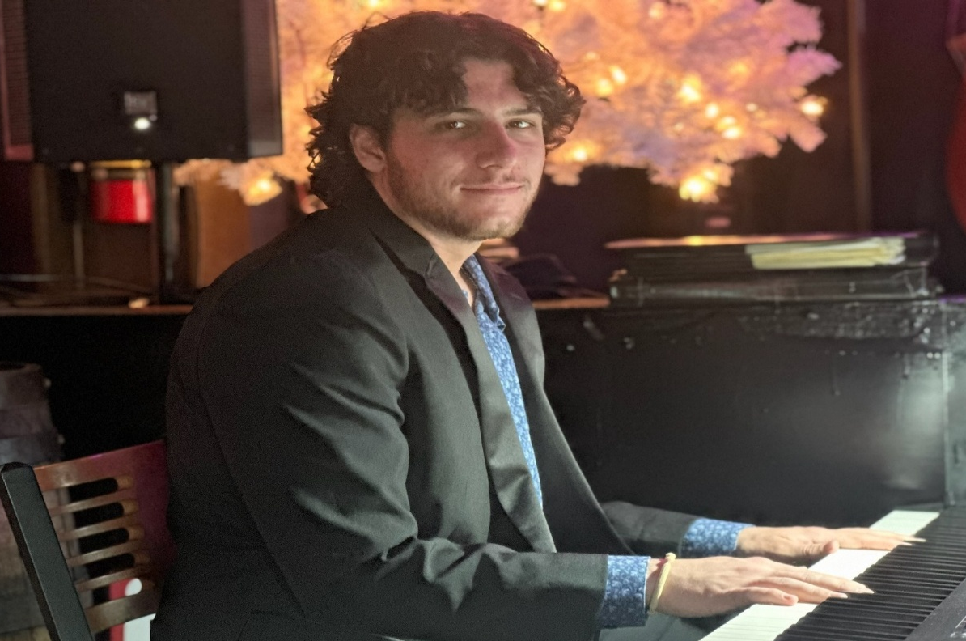

Wednesday April 16, 2025 – 7pm

Bethel United Methodist Church Chewsville,
21006 Twin Springs Drive, Smithsburg, MD 21783
301-733-8387 secretary@bethelumchurch.org

Solo piano featuring Dr. Joseph Yungen on organ.
Works composed by Brahms, Debussy, Mozart, and Rachmaninoff.
Reception to follow.

