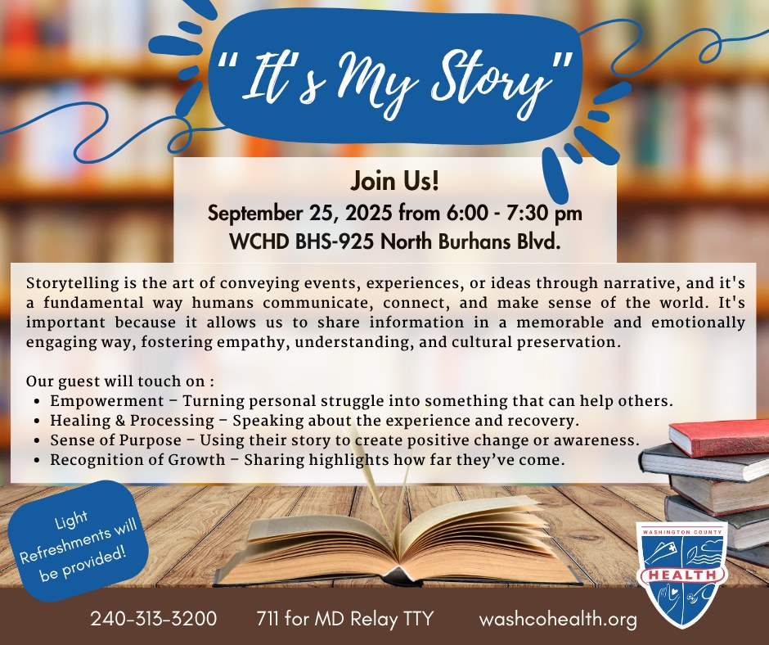

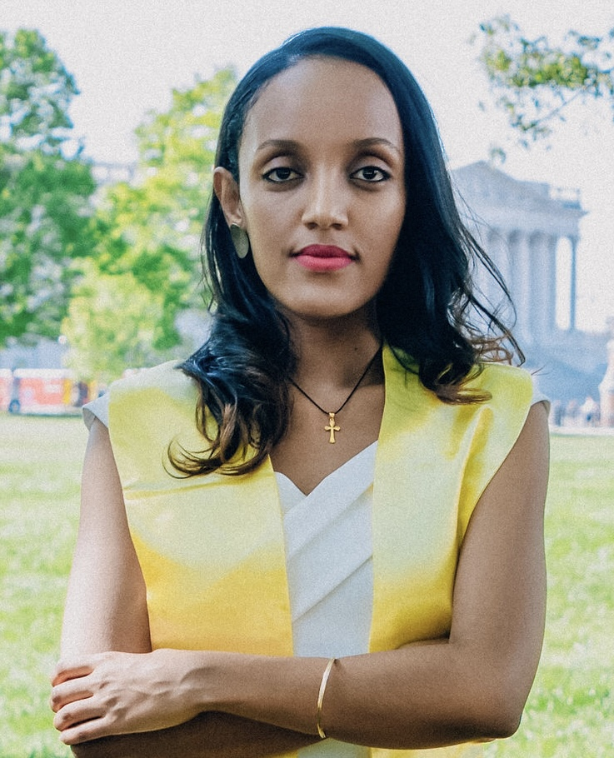

Ebise Bedye is a public health professional with a Master’s in Healthcare Administration and a Bachelor’s in Public Health. She has extensive experience in community health education and program coordination, working closely with underserved populations to design and implement impactful health initiatives. At the Washington County Health Department’s Behavioral Health Division, Ebise first served as a Community Health Educator, addressing behavioral health challenges, promoting prevention services, and fostering healthier communities. She now serves as the Coordinator of Special Programs (SOR IV) within the division.

****

Monica Johnson is a human services professional with over 25 years of experience in education and human services. Her background includes classroom teaching, case management, family support work, and recovery coaching; all work that strengthened her commitment to radical compassion. She currently works in nonprofit administration and as an adjunct professor in a teacher education program. Johnson is committed to lifelong learning, while preparing future educators to approach the field with empathy and joy.

Outside of her professional life, Johnson is a gardener, music lover, author, and avid reader.

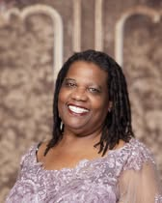

Alesia Parson McBean is a community architect, cultural preservationist, and dedicated advocate for equity and inclusion. Born and raised in Hagerstown's historic Jonathan Street neighborhood, she became the first Black elected official for the City of Hagerstown (2005–2009). As driving force behind The Doleman Black Heritage Museum, she works to honor and preserve the legacy of Black families, neighborhoods, and culture in Western Maryland. Through her leadership, she has organized transformative community events, cultivated collaborations across civic, nonprofit, and business sectors, and advanced the museum's $23 million vision for a permanent home. Known for her signature red lipstick—a symbol of resilience and purpose—Parson-McBean continues to shape spaces where history, culture, and community converge.

Rev. Kaye Coates has been a longtime member of Ebenezer A.M.E. Church in Brunswick, MD. She was ordained as a Local Deacon in 1999 by Bishop Vinton R. Anderson at the 49th Session of the Washington Annual Conference of the A.M.E. Church in Washington, D.C. She is the associate minister of Ebenezer-Brunswick, serving under the leadership of Pastor Emmanuel Johnson. Rev. Kaye attended Frederick Community College, Maple Springs Baptist Bible College and Seminary, and successfully graduated from an intensive one-year federal government management program. Born and raised in Knoxville, Maryland, she is one of eight children parented by the late George and Minnie Hardy. Rev. Kaye is the wife of Earl, the mother of Tamala and Angela, the grandmother of nine, and the great-grandmother of nine. She has a servant’s heart and readily does the work of the Lord. Kaye is a multi-talented individual who unselfishly uses her gifts and talents to benefit others. The generous outpouring of herself and her resources is legendary. Rev. Kaye is a poet and the author of “My Father’s Wisdom, His Daughter’s Heart.” True to her calling, she is a faithful servant to her church and community, but her overarching ministry is global by far.