Chair Yoga Series Continues at Otterbein United Methodist Church
108 E. Franklin Street, Hagerstown
Thursdays 11 a.m. – 12 p.m. in the Church’s Auditorium
March 13 – April 10, 2025 (5 weeks)
Suggested Donation $25

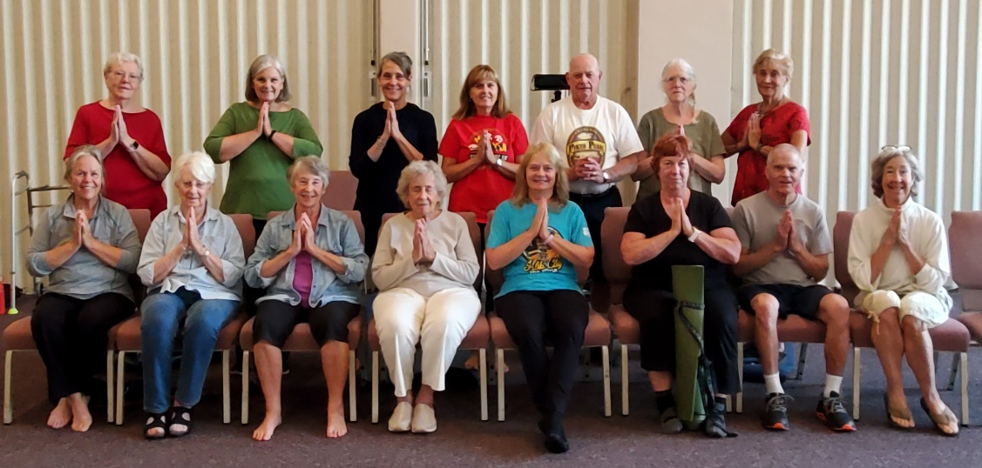

We’re looking forward continuing another 5 week series of Chair Yoga on Thursdays,
March 13 – April 8, 11:00 a.m. – 12:00 p.m. in the Church’s Auditorium. Jane Baer continues as our well-loved instructor. Jane is a 200HR Certified Yoga Teacher and has been teaching Yoga since 2007, in local Yoga studios and at the YMCA. She receives rave reviews from her students!

We are asking for a suggested donation of $25 for this series, payable at the first session. Cash or checks are accepted, with checks filled out to Otterbein UMC - Yoga in the memo line. Sorry we can’t accept credit cards. Scholarships are available upon request.

This chair yoga series is suitable for ALL levels and abilities. No previous experience is necessary. You will be guided through low-impact yoga postures from the comfort of a chair to increase flexibility, strength, and balance. Modifications for each posture will be given as needed. Additionally, we’ll practice breathing exercises and meditation to promote wellbeing and strengthen the connection between mind and body. You may choose to participate in bare feet, wear flat soled shoes or socks during the classes. Wear comfortable clothing that allows you to move freely.

To Register
Register on-line: https://otterumc.org/chairyoga, or e-mail Kate in the church office: office@otterumc.org or call 301-739-9386.

