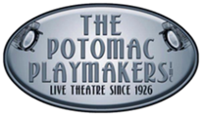The Potomac Playmakers is proud to present its first show of the 25-26 season, Second Samuel. With a healthy dose of humor, and a little added music, Pamela Parker’s original work, Second Samuel questioned some of the most divisive issues of the 21st century.
The story of Second Samuel steps out of all stereotypes and any, what you might call, narrative bounds. There really isn’t an individual hero, no specific protagonist other than the town itself. This tale is about the decisions and consequences that faced by the small community of Second Samuel GA, and ultimately, by each of our communities today.
At the heart of this story is this: What does “Love Your Neighbor” look like?
Race, Gender, and True Equality are all addressed with the grace and simple wisdom of a developmentally disabled young man named Bernard Flat.
Now, Miss Gertrude called him B-Flat ‘cause “There’s something musical about everybody”. But it certainly wasn’t B-Flat’s singing voice!
Directed by Cathy James and produced with kind permission from Dramatic Publishing. This show is rated G for a full family friendly experience. Performances run September 5-7 & 12-14, 2025. Each weekend includes a Friday night performance, and Saturday and Sunday matinees. General Admission tickets for all performances are $20 and $15 for Senior Citizens aged 65 and older. All tickets may also be purchased at the door or online at https://www.potomacplaymakers.org/get-tickets/.

A post show discussion of the play will take place after Saturday’s September 6 matinee. All are invited to participate.

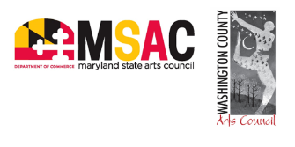
The Potomac Playmakers, founded in 1926, is one of the nation's longest running active community theatre groups. The Potomac Playmakers Performing Arts Center, purchased in 2017 with generous funding from the Agnita Stine Schrieber Fund, features deluxe cinema quality seating for a comfortable seating experience. For more information, visit The Potomac Playmakers’ website, email potomacplaymakers@gmail.com or call (240) 513-6260. The Potomac Playmakers, Inc. is a registered 501(c)(3adf) all-volunteer, non-profit organization.

