Volunteer Spotlight: Carmen Ortiz

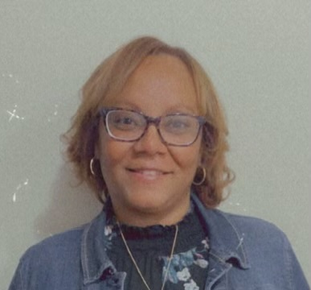
When Carmen Ortiz first began volunteering with Bloom, she didn’t realize she was stepping into something that would change her life as much as it would impact others. It started at Family Wash Day on Tuesdays, where she met Sheniqua Mitchell, Bloom’s Outreach Manager. “At first, we didn’t connect much,” Carmen recalls, “but one day I simply asked her if she needed help—and from that moment on, we started building something meaningful.” Drawn to Sheniqua’s passion for the BRACE (Be Ready, Alert, Courageous & Educated) youth program and outreach, Carmen found herself inspired by the way Bloom creates safe spaces for children and survivors to be heard.

Carmen officially began volunteering in late 2024, driven by a call to serve in a deeper way. Today, she works alongside Sheniqua at BRACE, mentors kids at the laundromat, joins speaking engagements to share her story as a survivor in long-term recovery, and participates in powerful awareness events like the Red Sand Project in Harrisburg. She has also helped educate healthcare professionals through a simulation with St. Luke’s nursing students—offering a first-hand perspective on the realities of trafficking and the role stigma plays in preventing survivors from getting help.

For Carmen, being part of Bloom is not just about giving back—it’s part of her own healing. “As a survivor, this work is inspirational and rewarding,” she shares. “Every day I’m learning more about who I am and how I can empower other women to reclaim their voices and lives.” Her lived experience, combined with her training as a Certified Recovery Specialist and Certified Family Recovery Specialist, gives her a unique ability to connect deeply with those Bloom serves. Whether mentoring youth, speaking to students, or simply showing up consistently, Carmen strives to help create the safe, empowering environment that is at the heart of Bloom’s mission.

Though she hasn’t been with Bloom for long, Carmen has already witnessed its growth—in partnerships, community presence, and the amplification of survivor voices. She’s seen firsthand how outreach efforts open eyes to the realities of trafficking and inspire people to be part of the solution. She even had the opportunity to speak with students at Cedar Crest College about recovery, trauma, and change—an experience she describes as “phenomenal.”

Outside of Bloom, Carmen works for Lehigh Valley Health Network’s Inclusion Health Mobile Team, serves in outreach through her church, and is pursuing a degree in social work at Northampton Community College with plans to continue at Cedar Crest. She is a proud mother, grandmother, and dog mom to Nova—her Fourth of July birthday twin—and will soon celebrate six years in recovery.

For Carmen, Bloom is more than a volunteer opportunity—it’s a place to live out her faith, use her voice, and show others that freedom is possible. “I’m walking proof that healing is real,” she says. “And I want everyone to know they can find it too.”

Thank you Carmen for all you do for Bloom and serving as a voice for survivors.
