Volunteer Spotlight: Jill Hellwig

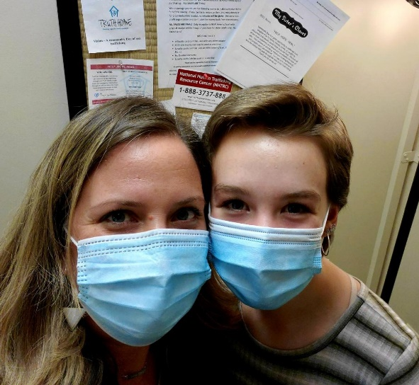
Jill explains. “In February, I began working for Trades of Hope, a mission-minded fair-trade company seeking to empower women out of poverty and extend education and restorative care to survivors of human trafficking. It is a direct sales job that allows me to partner with artisans in 19 countries, including our own, by selling the products THEY make so they can earn a fair, living wage in a safe and dignified workplace. I have been watching documentaries and reading books such as The Orphan Gospels by Shelley Jean, which teach about the cycle of poverty and how women in these poverty-stricken areas so often are lured into sex trafficking situations in hopes of being able to provide for their families. Devastating!”

Jill wondered about the prevalence of human trafficking right here in the Lehigh Valley, and literally googled these words: "Human trafficking near me." “This search is how I found Truth For Women (now Bloom). I was in shock that there would be an emergency shelter and restorative care program so close to home. How could this be needed HERE? In my own backyard? Finding this helped reveal the truth that this problem is global and doesn't exclude the Lehigh Valley. Now that I had joined with Trades of Hope, whose reach extends around the world, I knew I wanted to extend my reach to my own neighbors here at home, and that's when I considered volunteering with MSC.”

“I took my daughter and her friend to My Sister’s Closet in mid-February. When I saw all the postings about trafficking awareness around the shop, the Thistle Farms products, and the fair-trade coffee, I knew this shop's mission aligned with the mission of the company I am already working for, and being there solidified what I had already been thinking of doing, which was volunteering.” Jill filled out the paperwork that day.

Jill volunteers on Saturdays and says that she has already forged friendships here, “but the coolest part about my mornings with MSC is getting to share them with my 14-year-old-daughter, Abby. She has been with me every step of the way, from training to steaming to tagging. The days are long, but the years are short with her and these mornings in a meaningful setting TOGETHER with her, both of us knowing who benefits in the end from our work, is a BLESSING. Also, she has a My Sister's Closet shopping addiction!”

When asked how she feels what she does for us helps to further Bloom’s mission, Jill explains, “First and foremost, awareness is key. My work here allows me to share with others and open their eyes to the truth of what is happening not only in Thailand, not only in North Asia, but HERE. Second, my work is part of the network of teamwork that allows money to keep coming in. Programs like Bloom cannot function without funding! And programs like Bloom MATTER. I got to meet one of Bloom's survivors at the recent Flower Bar event, and putting a face to this mission was intensely impactful. All the behind-the-scenes work matters!”

A Sussex County, New Jersey native, Jill and her family settled in the Lehigh Valley after living in Maryland in order to be closer to family when her husband worked at Sanofi Pasteur.

“I have been married to Josh for 19 years and we are parents to three girls. Pray for us. Ha! We are so blessed because my parents just moved to our town of Nazareth so we finally get to live near family! What a gift!”

Jill recommends that others consider joining our volunteer team. “Your work in the back can seem tedious and trivial, but when you remember that there is a girl or a woman out there who has been told for who knows how long that she is worthless, you know how deeply important Bloom is and how important it is to fund it! These survivors need to know that God still loves them, God still can use them, they are valued. They are more than the horrific tragedy they've come through. We can't all be Liam Neeson in "Taken." We may not all have "a special set of skills" to fight the bad guys. But when we all do our part, a ripple becomes a wave. That's when CHANGE happens!”

