Volunteer Spotlight: Susan Lubbe

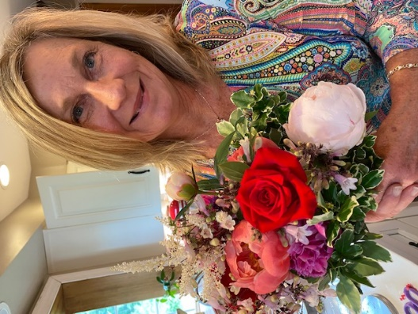
Susan is truly a blessing to Bloom. She shares her love of God and her passion for flowers to make a difference. Susan first became aware about Bloom when a dear friend of hers invited her to see the movie “From Liberty to Captivity” during Lehigh Valley Anti-Trafficking Week in 2019. Susan’s friend knew her well and knew she had a heart for survivors. Susan then attended a Friendsgiving Gift Card event at this friend’s home and that is where she met Carol Andersen!
“As I spoke with Carol, I learned that Bloom was faith-based and a creative restoration enterprise,” Susan shared. “My heart literally skipped a beat because I was previously involved in another ministry in New Jersey, which had a prevention education program. I mentioned that I would love to be a volunteer with Bloom in some capacity. That turned out to be an opportunity to teach a Holiday Greens workshop to benefit Bloom. That was November of 2020, and we’ve held two workshops since then. In January 2022, I felt compelled to pray and asked Carol how I could support Bloom in the new year – that is when “Pray with Us” began. Joining the team of volunteers for the Justice Revival event last September in making table arrangements was another new and exciting way to support Bloom. I love when my flowers can go to work!”
When you ask Susan what she does as a volunteer for Bloom, the first thing she says is “Pray! We meet on Zoom at noon on the second Monday of each month to intercede for Bloom. It’s been an amazing honor to see God working and healing and providing for staff and residents over the past 13 months. There is great power in prayer! It is the place where we give over our humanity and the things we can’t do, to the One who CAN DO! As much as our hearts long for our residents’ complete restoration, God’s heart longs for their healing even more. He is the Higher power who provides and heals!”
When asked how her involvement with Bloom has enhanced her life, she says “In one word: PURPOSE! I’ve always wanted my vocation to be my advocation. Bloom is an incredible community of individuals who share the same passion in making an impact against the horrors of sex trafficking and injustice.”
Although Susan did not grow up in the Lehigh Valley, her best friend did and for the past several decades she has spent a lot of time in the area. She says she is hoping to “jump river” from New Jersey when her husband retires.

After leaving her career in education in 2019, she created Gardens of Grace, a home-based business where she and her family grow Dahlias and a variety of flowers. She designs for weddings, events and holidays, but she really enjoys utilizing their flowers for restorative workshops, fundraising and sharing prevention education information with attendees. “Flowers have their own language and when broaching hard topics, they are healing to the heart.”
When she’s not focused on Gardens of Grace or volunteering for Bloom, she enjoys a weekly women’s bible study. And, she says that while the dahlias and garden is resting, she has become a bit of a ski bum. She loves to travel anywhere, near and far, but especially the mountains out west and visiting family in the Netherlands. She enjoys biking, hiking, gardening (of course), concerts and just hanging out with good food and friends. Her favorite local restaurant is Daddy’s Place in Easton.
Susan and her husband Ted have been married 31 years and have two daughters, Juliana and Rachel, and a future son-in-law, Mitchell, who they can’t wait to become an official part of their family in November. They also have a cat, Missy, who rules the roost.

