Staff Spotlight: Lauren Brennan
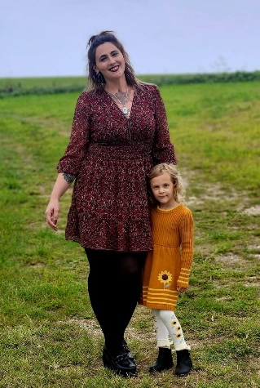
Lauren Brennan is a residential case manager for Bloom. She helps the women in the program with their daily activities from scheduling, getting rides to appointments, job searching, navigating public transportation, and managing their recovery journeys. When the ladies first arrive at Bloom, Lauren helps them get all their appropriate legal documentation, makes sure they get the medical attention they need and assists them with navigating any legal matters.

This role as a case manager comes naturally to Lauren as she has walked in the same shoes as the women in the program. She is a survivor!

“A little over three years ago, I was in rehab for substance abuse issues after a long and painful battle of unhealthy living. I knew that I had to spend a significant amount of time in an aftercare type program once I had left the rehab to ensure that I could maintain my sobriety. It was suggested by a counselor there that I should look into Bloom as it was a long-term program that was still local enough to my family. I can say with certainty that that woman saved my life that day.”

After leaving the program with a year of sobriety, Lauren went on to work on a horse farm and to restore her relationship with her family. She was injured about a year later and started working in drug and alcohol treatment. She reached out to Bloom’s CEO Carol Andersen to check in and say hello and mentioned she was looking for employment. She said “I was lucky enough to learn of the case management position available and with my experience of being a participant in this program and working in treatment, it seemed like a great fit! I just reached my one year working for Bloom and I am forever grateful for this opportunity!”

As case manager, she is responsible for keeping track of two of Bloom’s five homes. She keeps them tidy and stocked with essentials to help daily life run smoothly. “Each lady is unique and there is always something new to learn and cherish about every participant that comes through our doors! It never ceases to amaze me how much strength and willpower these ladies have. When I see the growth in them, it shows me that this organization is doing amazing things. I know that without the incredible staff, volunteers, and board members that we have, we would not be where we are today. I am grateful to be a part of this team and it excites me to open the doors to another woman out there who is struggling.”

“I can honestly say that I would not be the woman I am today without this program. Not only did they help facilitate me gaining a life that I could never imagine, but I am now granted the opportunity to help other ladies achieve the same. I learned the most valuable lessons during my stay as a participant and I continue to learn and grow as an employee. The most exciting enhancement is that I have reignited my passion for learning and have gone back to school in the hopes of becoming a doctor in Psychology one day.”

When asked how things have changed since she first came to Bloom three years ago, Lauren said “WOW! Is really all I can say. It has grown in leaps and bounds since then. I have witnessed the incredible ability of this program to change and evolve to best suit our participants in ways that are unfathomable. I learned as a participant here that we must always remain teachable, and it is heartwarming to know that this organization really holds true to that sentiment. I know that if something isn’t working, there is always a solution and that the team will always have the best interests of everyone involved in mind.”

She encourages others to get involved with Bloom. “We are always growing and as a non-profit, we are always in need of help with that growth. It truly takes a village!”

Lauren has made the Lehigh Valley her home. She was born in Buffalo, NY, grew up in Ithaca, NY, and moved to the Lehigh Valley as a young teen. She has lived in and out of the Lehigh Valley throughout her adult life and says “somehow always end up back here”.

When Lauren isn’t working, she keeps busy. “I have always had a passion for horses and equestrian sports. I work mornings on a horse farm where I clean stalls, feed and turn out 24 horses.” She has also volunteered at a local horse farm that does a lot of equine therapy activities. She taught riding lessons there and spent a lot of time learning the therapeutic value of horses.”

“I am also a car enthusiast,” she adds. “I love to go to shows/meets and I have a 1998 Volkswagen TDI that is my project car. I ski and snowboard in the winters and kayak and longboard in the summers. I enjoy art and have spent many hours in the Bloom Creative Studio working on various projects.”

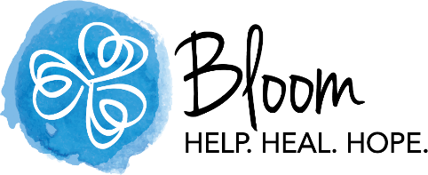
“My family consists of my beautiful and amazing four-year-old daughter, Evelyn, our little chi/terrier mix, Penny, and my amazing support network of biological and chosen family that I would be lost without!”

Thank you Lauren for sharing your experience and expertise with the women of Bloom. We are so proud of you and grateful that you are part of the Bloom team.

