Board Spotlight: Tiffany Sondergaard
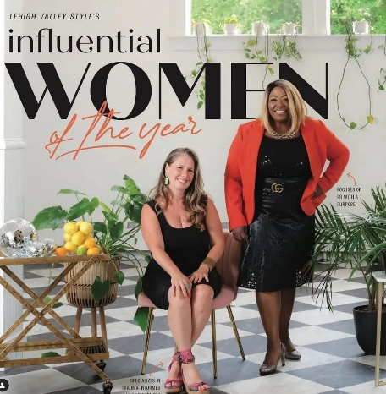
Our board member, Tiffany Sondergaard, says she “gives back relentlessly to many organizations,” and here at Bloom for Women, we want to thank this energetic businesswoman and community leader for making our mission such a blessed recipient of her professional talents, compassion and generosity!

Tiffany first learned about Bloom while working with a local domestic violence awareness nonprofit. While planning their annual fundraiser, she was looking for sister organizations to highlight at the event. Her search resulted in our Director of Development, Vickie Nisbet, giving a presentation on behalf of Bloom for Women. Tiffany joined Bloom’s board in January of 2022.

“I handle media relations for Bloom. My company is now --ts Brand Elevation.” In addition to her board role, Tiffany explains that she looks to serve as Bloom’s PR agency of record, supporting media relations and special event marketing. As founder of --ts PR & Event Planning, she has extensive experience in the design and execution of national publicity campaigns, strategic marketing communication programs, and special events for major brands. She was recently recognized as one of Lehigh Valley Style’s 2022 Women of the Year.

Tiffany adds that her own awareness has been enhanced through her efforts to further Bloom’s mission. “First, I now understand that the Lehigh Valley is a trafficking hub close to an airport and major highways. My involvement with Bloom has been incredibly rewarding. and enriched my life by allowing me to bring awareness, through media coverage, to a major problem happening right in our back yard. With public relations, I am able to contribute to a cause I am passionate about and see firsthand the positive changes we can bring to our community. By handling media relations and special event marketing, I help increase awareness of Bloom’s mission and initiatives. Effective communication and publicity are essential for reaching potential supporters, volunteers, and donors. My work ensures that Bloom's message is conveyed clearly and widely, helping to attract the resources needed to support survivors of trafficking and modern day slavery.”

“Since I first joined Bloom, I’ve seen the organization grow in terms of community engagement, support, and expansion of services. There’s been a noticeable increase in awareness about our mission, more partnerships with local businesses, two more homes, including one specifically for mothers, and now a podcast. Bloom is always evolving to meet the needs of the women whom it helps!”

Tiffany also serves on the American Advertising Federation of Lehigh Valley and is Co-Chair of YWCA Allentown The Perfect Fit's Outfit to Empower event coming up this October.

Having been a New York resident, marriage to her husband, Tom, brought Tiffany to the Lehigh Valley 20 years ago. “I am raising a family that I help support as an entrepreneur and business owner. I give back relentlessly to many organizations, and gave my life to the Lord Easter, 2022.” Tiffany and Tom have two sons, David and Tarin, and a daughter, Nya.

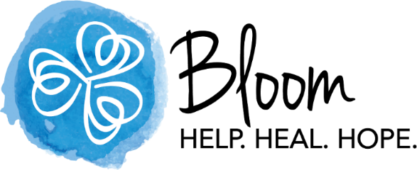
Tiffany describes herself as an avid reader and “serial networker” who is “always up for taking a flight to somewhere new.”

Thank you, Tiffany, for all that you do for Bloom for Women!

