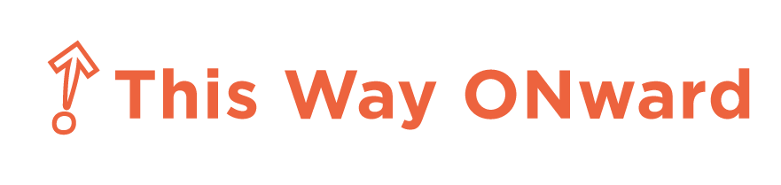

Are you between the ages of 16 and 24?
Are you interested in working at Old Navy?

This Way ONward is a paid internship program
designed to provide young adults
an opportunity to
gain leadership skills
and confidence
in a competitive work environment.

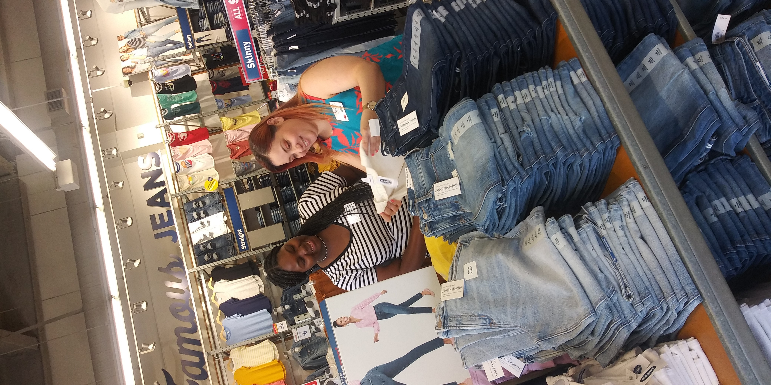
Internship roles include:
- Sales & Sales Support
- Shipment
- Fitting Rooms
- Merchandise Replenishment
- Store Visuals

Program Phases:
- April--May:Goodwill provides Job Readiness Training
- May--Qualified participants apply for internships
- May 24--27 Interviews
- June 1--Selection
- June 13--August 21: Interns work a minimum of 12 hours a week for 10 weeks
- Qualified interns may receive offers for ongoing employment.
RECRUITMENT FOR 2021 HAS BEGUN!
If you are interested in a This Way ONward Internship, please email:thiswayonward@ging.org
or call:1.844.344.9675

If you are interested in our This Way Ahead Internship, please email us at:
thiswayahead@ging.org
or call:

