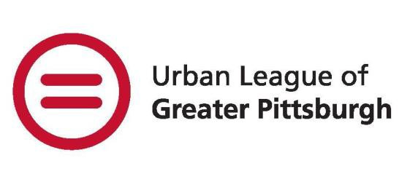

Black Female Leadership Development Institute
2022-2023 STUDENT APPLICATION

The Black Female Leadership Development Institute or BFLDI is a program that brings African American young women in grades 9 through 12 and between the age ages of 13 and 18, together to participate in an institute, increasing their educational and leadership opportunities. Students will improve practical skills such as networking, communication and leadership in order to have an impact on local, national and global communities. BFLDI is a multi-faceted program that encapsulates dynamic workshops and student discussion groups. The students will be offered a wide-range of already existing Urban League programs including STEAM-related content in our Tech U suite and financial empowerment.

BFLDI will tentatively operate as a hybrid model for the program year. Participants will attend both in-person and virtual sessions. These plans may change based on new information regarding the Covid-19 pandemic.

WHAT GIRLS GAIN FROM OUR PROGRAM:
- Emotional Support | - Identity Development | - Advocacy & Research Skills
- College/Career Readiness | - Health & Wellness | - Global Awareness
- Personal Brand Marketing & Social Media Etiquette | - Public Speaking & Communication Development | - Professional Development & Networking

ELIGIBILITY REQUIREMENTS and PROGRAM COST
Student must be ages 13 to 18 years old and enrolled in high school.
The Program is FREE due to the generous support of donors.

DRESS
The dress code is generally casual. Occasional sessions will require participants to dress in business or formal attire. Participants will be notified in advance regarding the dress code for special events.

PROGRAM OVERVIEW
The start of the 2022-2023 program for students will begin on September 7, 2022, with the virtual BFLDI Kick-Off Day. Sessions will follow in September with weekly sessions and monthly Saturday Leadership Institute workshops. The program will end June 2022.

Saturday Leadership Institute workshops will be facilitated by professional women in the Southwestern Pennsylvania region who will expose participants to multiple facets of leadership, financial empowerment, STEM/STEAM related careers and topics, communication and problem-solving. Students will participate in nationally recognized leadership programs.

All participants will become members of the Girl Scouts of Western Pennsylvania and will form their own troop. Students will work towards badge completion through the
Girl Scout curriculum.

Computer access and internet capability are required. The program will use Zoom and/or Microsoft Teams for virtual sessions.

APPLICATION PROCESS
The BFLDI program will accept applications on a rolling admission basis. Applications are accepted until the cohort is filled, so it is recommended that applications are submitted as soon as possible. Applicants will be contacted to schedule a date and time for a follow-up interview. All interviews will be conducted virtually. Students will be notified of the admission decision.
.

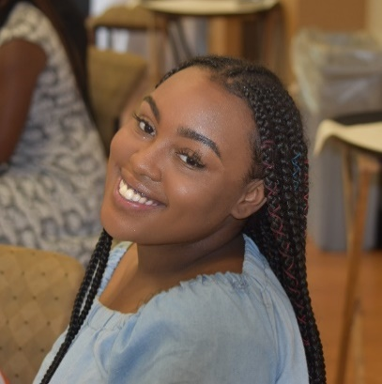
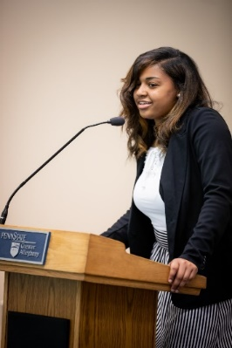
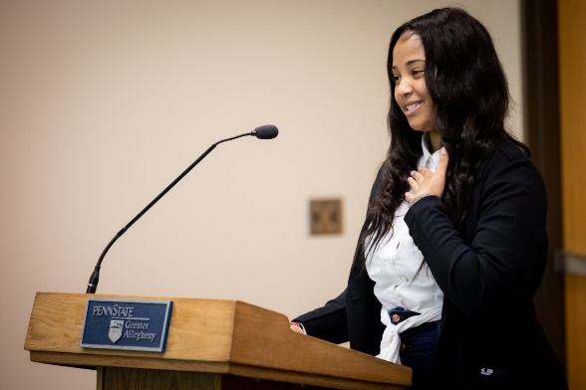

Student Demographic Information

Please check the box below to specify your attendance and commitment to BFLDI:

Online, Wednesdays, 4:00 pm – 5:30 pm - Saturday Institute Workshops: On-site 332 Fifth Ave., 4th Floor

Student Contact

First Name |  | Last Name
Address |  | City
State |  | Zip code
Email |  | Cell  Number

Race: White Hispanic/Latino Asian American African American Other

Student Date of Birth Current Age ______ Current School ______________________________

Grade Current GPA __________

A copy of student’s most recent report card is required.

Parent/Adult Contact -1

First Name |  | Last Name
Email Address
Cell Phone  (Day #) |  | Alternative Number
Relationship

Parent/Adult Contact -2

First Name |  | Last Name
Email Address
Cell Phone  (Day #) |  | Alternative Number
Relationship

Student Questionnaire

Why should you be selected to participate in BFLDI?

________________________________________________________
- What career field(s) are you interested in?

• • •

Define leadership in a few words.

_________________________________________________________________________________________________________________________________

- Does everyone have purpose? Please explain.

______________________________________________________________________

- If you could do one thing to change the world, what would it be and why?

___________________________________________________________________

- Name three strengths you possess and why you appreciate having them.

______________________________________________________________________

- What leadership attributes would you like to gain from participation in the program?

How to Submit Your Application

Application Material Checklist
Student Demographic Information
Student Questionnaire
Most Recent Report Card

How to submit your application?

Mail or Fax your application to:
BFLDI
Urban League of Greater Pittsburgh
332 Fifth Avenue, 4th Floor
Pittsburgh, PA 15222

Electronic Submission:
E-mail to: gunderwood@ulpgh.org
Put in the subject line “[Your Name] Completed Application

For additional questions:

Ginger Underwood, MS

Program Manager

Work: (412) 227-4815
Email: gunderwood@ulpgh.org
Fax: 412-471-6199

