


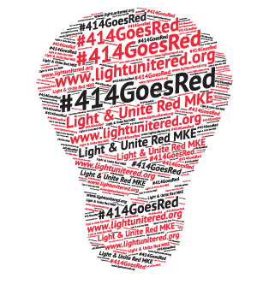
Light and Unite Red Resource Fair

Vendor Registration Form
Tuesday, March 31st
4:00pm to 6:00pm
Owen’s Place
4610 W Fond du Lac Ave, Milwaukee, WI 53216

Name of organization: Click here to enter text.
Number of Representatives: Click here to enter text.
*Registration includes 1 table and 2 chairs. Pease bring your own tablecloth/banner*

Contact Information of Representatives:
Name: Click here to enter text.
Email: Click here to enter text.
Phone: Click here to enter text.

Name: Click here to enter text.
Email: Click here to enter text.
Phone: Click here to enter text.

Description of information to be provided: (brochures, giveaways, etc.)
Click here to enter text.

Signature: Click here to enter text. Date: Click here to enter a date.
Event logistics, setup information and more to come. Please send form and any questions, to Caitlin Vicini at CVicini@chw.org

