August, 2018

GRAND AVENUE CLUB SEEKS FULL-TIME STAFF WORKER

Grand Avenue Club (GAC) (www.grandavenueclub.org) in Milwaukee, Wisconsin is currently soliciting applications for a full-time Unit Leader in our Administrative Unit starting in January, 2019.

This job involves working with members and staff on a variety of administrative tasks, including recruiting and initiating new members, assisting members with paid employment as well as training and supporting them on the job, leading work support groups, and doing absentee coverage in our Transitional Employment Program. Benefits training and experience would be a real plus. There is some evening, weekend, and holiday work.

The successful candidate will have a strong work ethic, a collaborative style, enthusiasm for the GAC mission, flexibility, and relevant experience. A bachelor’s degree is required; a master’s degree is preferred. A car, driver’s license, insurance and a good driving record are required.

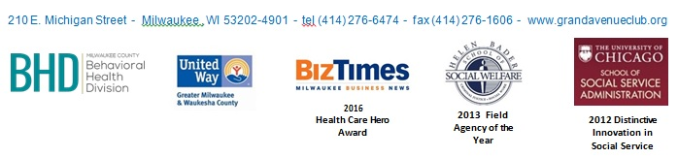
Cover letters and resumes should be sent to rzforman@yahoo.com with “GAC Program Staff 2019” as the subject heading and must be received by Friday, November 30, 2018

