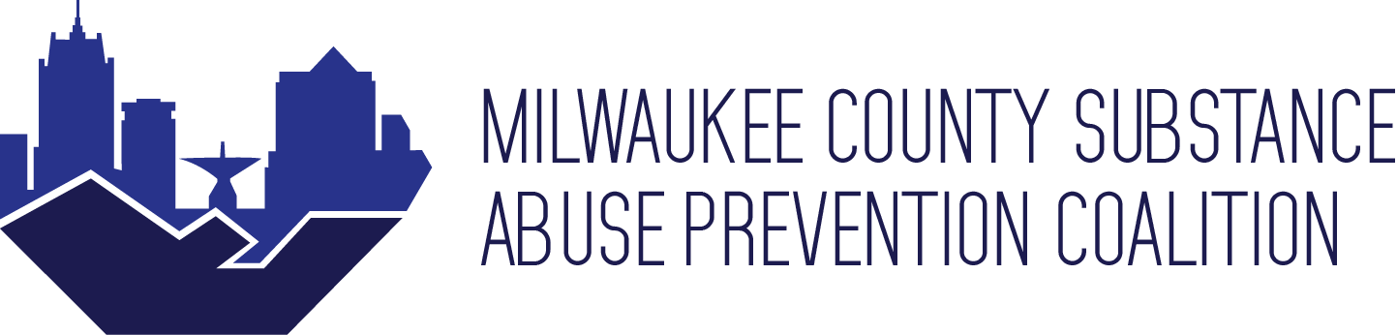

**Date & Time:** Thursday January 27th, 2022 12:00pm - 1:30pm

**Agenda**

1. **Arrival (12:00)**
2. **Introductions/New members**
   * **Name, organization, Pronouns**
3. **Ice breaker-Would you rather?**
4. **MCSAP and coalition member Announcement: (12:10 -12:25)**
   * + - Setting expectation
         1. Words we are getting away from:

“**Drug abuse 🡪 drug use or misuse.”** “**Drug abuser/addict 🡪 person with a substance use disorder.”** Remember: Not everyone feels the same way about certain words and may label themselves one way or another

* + - * **Light Unite Red Week March 26th-April 6th, theme mental health and wellness, drug prevention, and reducing stigma. (center around family events)**
      * **Does anyone have any connection to local Culvers?** 
        1. Mini grant-10 $2,500 grants: **This grant is for any nonprofit organization in the Milwaukee county area that targets substance use and misuse prevention. If you need the grant application, contact Alexandria Kohn**
      * We are rebranding with Pinpoint Solutions! New name, logo, tagline, colors.
      * Art therapy sign up
    - Member announcement

1. **What do we want to see from MCSAP this year? (12:25-12:40)**
   * + - Going over jam board ideas
2. **Whip-Its full group discussion Group (12:40-1:00)**
   * + - **Should we scrap this idea and focus on something else?** 
         1. **What do we need to get started on this project?**
         2. **What is key information missing?**
         3. **What do the groups need from each other?**
       - **What would be something else?**
3. **Workgroup mini breakout group (1:00-1:10):** 
   * **Check in with each other**
   * **Have one action item to leave meeting**
4. **Closing and report out (1:10 – 1:30)**

* Meet with someone new (Five minute activity)

***Next Meeting:TBD***