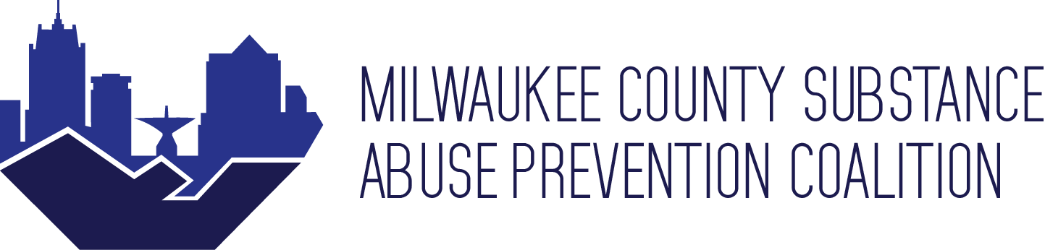

Date & Time: Thursday September 22, 2022 12:00pm - 1:30pm CST

Agenda
- Arrival

- Introductions/New members
      - Ismael Luna, MCSAP Coordinator
      - First-time meeting attendees

- MCSAP updates
      - Rebranding
      - November Full Coalition Meeting Survey

- Presentations (12:15pm – 1pm)
      - Data Update – Nicole Fumo
      - Overdose and Suicide – Sara Kohlbeck, Director of Suicide Prevention at MCW

- Member updates

- Group Breakouts
      - Mental Health and Wellness
      - Whip-it survey group

- Closing

Next Meeting: November 2022

