August, 2018

GRAND AVENUE CLUB SEEKS FULL-TIME STAFF WORKER

Grand Avenue Club (GAC) (www.grandavenueclub.org), is currently soliciting applications for a full-time Staff Worker in our Education/Employment Unit.

This full-time job involves working with members and staff in running GAC, recruiting members to paid employment, training and supporting members on the job, and doing absentee coverage in our Transitional Employment Program. There is some evening, weekend, and holiday work.

The successful candidate will have a strong work ethic, a collaborative style, enthusiasm for the GAC mission, flexibility, and relevant experience. A bachelor’s degree, a car, driver’s license, insurance and a good driving record are required.

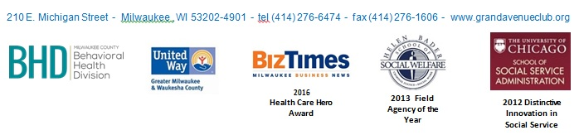
Cover letters and resumes should be sent to rzforman@yahoo.com with “GAC Program Staff 2018” as the subject heading and must be received by 5 p.m. on Friday, September 7, 2018.

