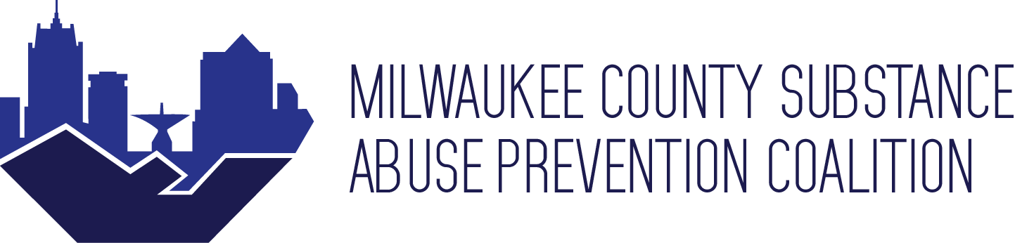

Date & Time: Thursday, September 17th, 2020 12:00pm - 1:30pm

Agenda
- Arrival (12:00)

- Community Advocates Announcement: (12:05 -12:15)
      - Announce Alex’s Onboarding as MCSAP Coordinator and Jeremy as MCSAP Mental Health and Wellness Coordinator
      - My Friends: Youth Video – https://www.youtube.com/watch?v=Dar3U12n_9U&list=PL6guVwdTpkEM1oNDSyBUNE68G8k56B1AH&index=4

- Presenter- Vaynesia T. Kendrick, B.S., M.S., Community (1:00 - 1:15)
City of Milwaukee Office of Outreach Specialist- Suicide
Prevention and Violence Prevention – Strong Babies Program
- Intersectionality of Suicide and Substance Misuse
    - Suicide is the 10th leading cause of death for adults and the 2nd for youth
      - There have been 2,400 overdoses in Wisconsin this year
      - Drugs are being glorified to the youth
    - We need to have the conversation to youth about suicide
    - Parents and other family members have increased substance use since Covid-19 has begun impacting life

- Workgroup Break Out (12:15 -12:35)
  - Presentation Breakout Questions: •
      - How can our coalition integrate this information into our work?
      - What can our working group do with this information?
      - How can CA better support you with this information?

- Intro/ Workgroup Report Outs (12:40—1:00)
• Multi-Drug Prevention Workgroup
      - Need more key speakers for meetings
      - Youth are exposed to suicide, drugs and violence through media
      - We need to find ways to feel more prepared to have conversations on suicide
      - What we need from CA is space for more connection among MCSAP members as well as more exposure to real life stories on others and their journey. Lastly a list of resources that we can count on to refer youth to.
• Prescription Drug Prevention Workgroup
      - They did a mental health check in with each other
      - What they need from CA is more mental health check-ins and conversations revolving around coalition members mental health and status.
• Data/Evaluation Workgroup
      - How much does the community know about the suicide rates since Covid-19?
      - Youth no longer have access to school social workers and school counselors to be able to talk about suicides and overall well-being.
      - Normal drug supply routes have been affected and individuals might be going to other drug dealers not knowing what they are getting which might lead to drug overdoses.
      - What we need from CA is more virtual focus groups, conversations, and solutions to decrease suicided and overdoses.

- Closing (1:15 - 1:30)
- Speaker Recommendations For Next Coalition
    - Life change, a client who survived her suicide attempt
    - Native Connection, new coordinator
- Member Announcement/ Events
    - Parenting network, a chance for parents to connect during Covid-19

Next Meeting: November 19th, 2020; 12:00-1:30pm

