Teaching Climate Change in Just 45 Seconds: Three Easy Scripts
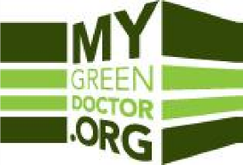
How can we talk with our patients about the health risks of climate change without disrupting the medical visit? This important topic can be time-consuming and even controversial. This month, the ACCMA’s My Green Doctor explains an easy solution that may work well in your practice: https://www.mygreendoctor.org/teaching-patients-climate-change-in-just-45-seconds-three-easy-scripts/ .

My Green Doctor is a free money-saving membership benefit for members of the Alameda-Contra Costa Medical Association. Medical offices use My Green Doctor’s “Meeting-by-Meeting Guide” to learn how to adopt environmental sustainability, save resources, and help create healthier communities. The program adds just five minutes to each regular office staff meeting or weekly office “huddle”, making small changes at each meeting that over time really add up.

Everyone in your practice can register as Partner Society members at www.MyGreenDoctor.org or at www.MyGreenDoctor.es (si, en Espanol) and can use the discount code MGDACCMA to save $60 instantly and give full access to My Green Doctor for free. Ask your clinic or practice manager to register today and to put My Green Doctor on your next agenda. You can do this!

