YOUR ROYAL INVITATION TO THE 2016 PRINCESS BREAKFAST
Sweetest Day With Your Princesses
Saturday, October 29^{th, 2016}
9:00a.m. @ SUMMIT VIEW MIDDLE SCHOOL
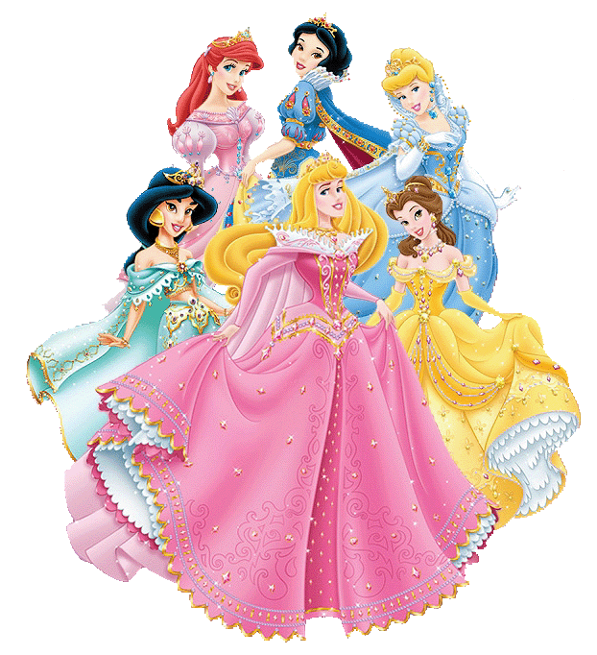
$20 Per Child which Includes one free adult:
Breakfast With The Princesses
Tiara, Candy, Glitter Nail Painting
Kids Jewelry, Wand Craft
4 x 6 Photo With The Princesses
Dance With The Princesses

Presented by Pioneer Tennis Boosters
All Proceeds Benefit Simon Kenton High School Tennis Teams

******TICKET ORDER FORM******
- COST is $20.00 per child which includes one free adult. $5 per additional adult. Proceeds support Pioneer Girls/Boys Tennis Teams. Please make checks payable to Pioneer Tennis Boosters and mail them to Attn: Virginia M. Riggs-Horton, 4162 Farmwood Court, Erlanger, KY 41018. An email confirmation will be sent and tickets will be picked up the day of the event.
- Any questions, please contact Virginia M. Riggs-Horton at 859 866 0228 or via email at virginia.riggs@yahoo.com

Child(ren)’s First Name(s) ___________________________________________________
Parent/Guardian Name ______________________________________________________
Address: ___________________________________________________________________
Phone: _____________ Cell ____________ Email _______________________________
# of Tickets ____@ $20.00 each + ____ add'l adults @ $5.00 each = ___________ Total

