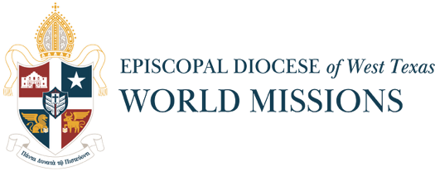

2026 MISSION FUNDS REQUEST FORM
Please limit your responses to these two pages. Please do not submit a request if the funds will not be used in 2026. Forms are due in the DWTX office to Catherine Markette (catherine.markette@dwtx.org) by January 15, 2026. Requests received past the deadline will be considered on a first come/first served basis.
A report of 2025 missions activity with pictures must be attached to your request form. Reports and pictures submitted online are preferred to hard copies. Data should be included. Grants are limited to requests for missions outside of the US and are decided upon by a select committee. Recipients will be notified in March of 2026. Please note that we are not able to fully fund entire projects.
- Name of project:

- Team leader(s) and team members:

- Church(es) participating:

- Description of project/ministry:

- Amount requested:
- Amount requested as percentage of total amount needed:
- Source(s) of other funds:

- When are the funds needed?

- Requested by:

- Phone Number: Email address:

- Ministry Website address (if applicable):

- Rector's signature:

- Church Mailing Address:

Impact of Mission in 2025:
Number of people served ________
Number of patients treated ___________. Types of illnesses seen _______________________________ _____________________________________________________________________________________
How many Bible studies did you teach? ___________ How many participants? ___________________
How many people received clothing?_____________ Other items distributed?_____________________
_____________________________________________________________________________________
How many classes (and what) did you teach?________________________________________________
How many buildings (and what) did you build or repair and what were they?______________________
____________________________________________________________________________________
How many pairs of glasses/tools/books/computers/etc. did you present to your partners?___________
____________________________________________________________________________________
How many scholarships were presented to how many students and for what studies?_______________
____________________________________________________________________________________
How many animals were treated?________________________________________________________
What other ministries were part of your mission?___________________________________________
Anything else?_______________________________________________________________________

Did the team or individual members participate in any WM Committee/Department activities in 2025? Check those that apply: __Mission Café webinars; __Monthly Zoom Prayer Meetings; __Mother’s Day Offering;
__Fishin’ for Mission Tournament;__Texas Water Mission Fundraiser; (auction, table sponsor); __Back to School Collection
Please be creative if something has been left out. We want our diocese to have a better understanding of the broadness of missions ministries and the number of people touched by God’s love.

