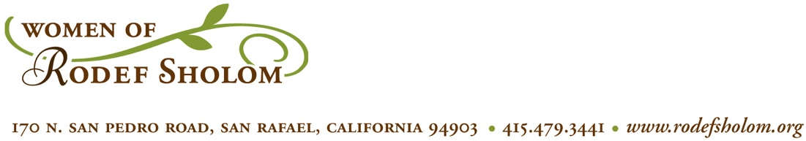



**Women of Rodef Sholom Calendar of Events 2019-2020**

First Tuesday of the Month WRS Board Meeting Brandeis Library

Thursdays TBD Chai Mitzvah Classes Brandeis Library

**2019**

August 25, 11:30am – 3:30pm Pool Party Toni Golbus’ home

September 15, 3:00-5:00pm Opening Event Rodef Sholom

September 22 Women’s Mikvah JCC Pool

November 8, 6:15pm Sisterhood Shabbat Rodef Sholom

December 8, 3pm – 5pm Hanukkah Social CRS Social Hall

**2020**

February 1 Trivia Night CRS Social Hall

February 9, 11am – 2pm Jewelry and Accessories Sale JCC Lounge & Atrium

March 29 Sisterhood Seder CRS Social Hall

May 15-17 WRS Retreat Westerbeke Ranch

May TBD Mother’s Day Boutique Venetia Valley School

June 6 or 7 Social Event CRS Social Hall or JCC

