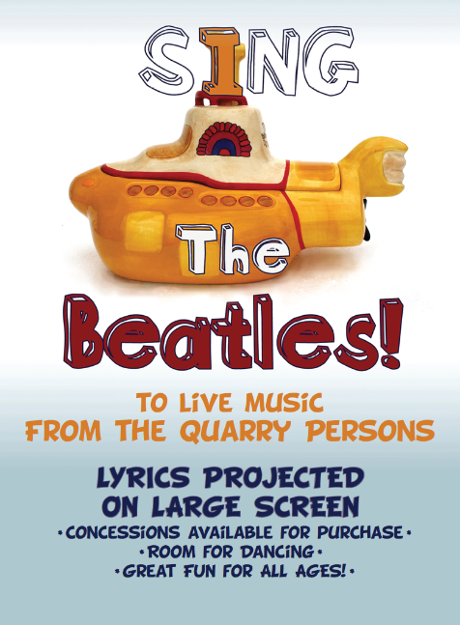

Kanbar Center for the Performing Arts @ the Osher Marin JCC presents:
Sing the Beatles with THE QUARRY PERSONS!
Saturday - November 17@ 7:30 PM

CRS Sisterhood Special – $10 Tickets!
(advance online purchase only)

Bring family & friends to “PUB J” for a fabulous night of fun, singing along to your favorite
Beatles songs! The Quarry Persons (featuring our very own Amy Friedricks!) perform live.

Lyrics will be projected on the big screen so you won’t miss a word!

The Hoytt will be set pub style with concessions inside, cabaret table seating
(special tables will be reserved for Sisterhood tickets!) and cozy couches in the back. Sing, dance, and move to the groove of your favorite Beatles songs. Here’s your opportunity to share that voice you’ve been keeping for the shower!

The Quarry Persons have led standing room only Sing the Beatles events for the San Francisco Free Folk Festival for several years, have rocked the Kensington Circus Pub, and have sold out! at Berkeley’s Freight & Salvage.

CRS Sisterhood….. Use Promo Code: SISTERS
For direct link to Eventbrite ticketing click here and follow directions starting at #2 below

For additional event info click HERE. To purchase tickets from the event info page:

- Click on the red Tickets button (this will take you to the Eventbrite ticketing page)
- Click on the green Ticket Button
- Enter Promotional Code (SISTERS)
- Then select the number of tickets.
- Complete purchase

For questions, please contact Heidi Paul, hpaul@marinjcc.org / 415-444-8089

