SummerFEST
Saturday, July 6, 2019

Vendor Information

FIRST COME, FIRST SERVE
Please remember:
No pets, No ATVS,
No fans or other unnecessary appliances
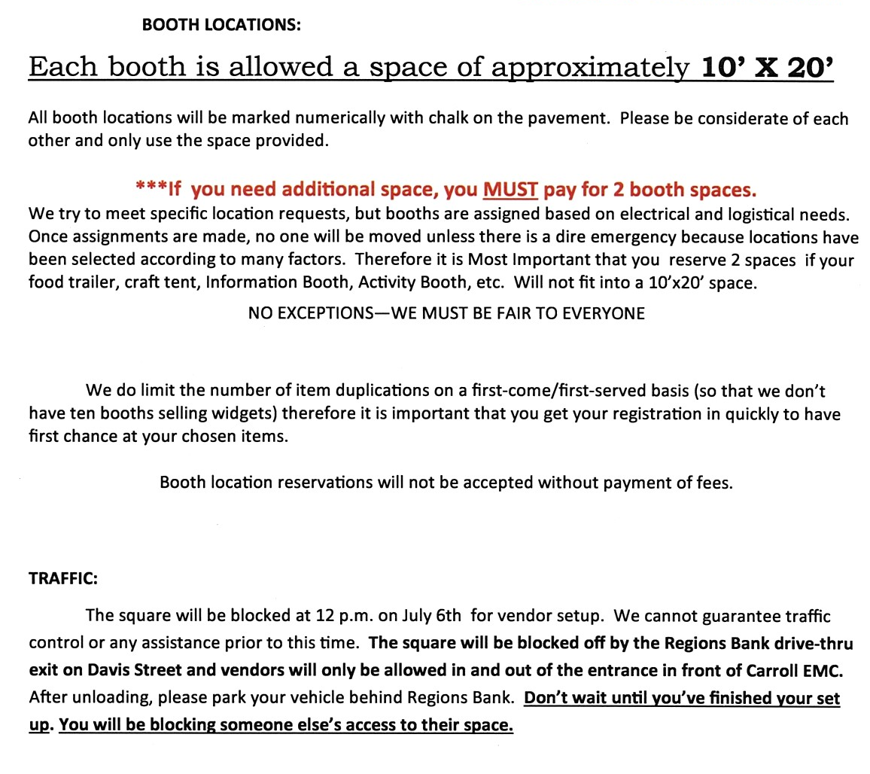
July 6, 2019 / 5:00pm to 11:00pm

