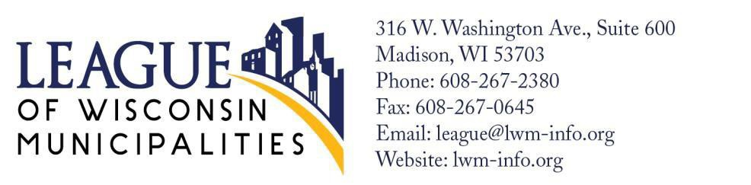

For immediate release June XX, 2023

Contact Name, Title, Phone number, Email

Shared Revenue Bill Signed into Law

The Local Government Funding Legislation, Assembly Bill 245 (Shared Revenue Bill), was signed into law as Wisconsin Act 12 Tuesday, June 20, 2023, by Governor Evers in Wausau.

Assembly Bill 245 dedicates one penny of the state's sales tax to fund local units of government beginning July 1, 2024. The legislation also provides a supplemental inflationary increase and attaches both current shared revenue and the supplemental payment to the growth in the state's sales tax moving forward.

With this bill, all communities will see at least a 20% increase over current municipal aid. The City/Village of _______ will receive a _______% and this will help support our essential local services. (Expand in detail if you are able).

(Add a quote from your City Manager, City Administrator, Mayor, or President expressing their reaction to the bill and how it will affect your community directly).

Additionally, the bill will allow Milwaukee to receive a 10% increase and the local sales tax authority., and there has been a complete repeal of personal property tax, with state backfilling lost revenue.

Wisconsin’s system for funding critical local services like police, fire protection, EMS, water, sewer, well-maintained safe streets, and parks, has been broken, unsustainable, and needed to be reformed. Assembly Bill 245 will do just that.

With state sales and income tax revenues tripling in the last 30 years, the share of those taxes going to support police, fire, EMS, and other municipal services has gone down. The funding level for County and Municipal Aid in 2003 was $938 million. In 2023, it is $753 million. This steady decline in the investment to fund critical local services has forced communities to rely more heavily on property taxes to maintain the type of environment that attracts businesses, residents, and tourists. With the passage of Wisconsin Act 12, the property taxes will no longer shoulder the entire burden to pay for critical local services., This legislation provides a sustainable, growing source of revenue for local government, increased state support for public safety, and a continuation of the state’s growing investment in local transportation needs.

This bill was signed into law due to all the effort and support from Speaker Robin Vos, Senate Majority Leader Devin LeMahieu, Senator Mary Felzkowski, Representative Tony Kurtz, Governor Tony Evers and all the Senators and Representatives who voted for this bill. The City/Village of ______ appreciates their work to assist local governments with critically needed funding. This is a historic investment for communities of all sizes in Wisconsin.

###

(City/Village Mission Statement here- League’s is below for example- remember to remove ours before sending)
The League of Wisconsin Municipalities advocates for Wisconsin’s cities and villages, large and small, urban and rural, speaking up for local democracy and common-sense citizen led government.
Learn more at http://www.lwminfo.org/

*Don’t forget to change the top logo to your City/Village and to add the address to your City/Village Hall.

