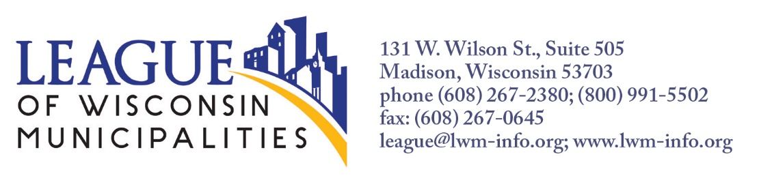

To: Senate Committee on Financial Institutions and Revenue
From: Toni Herkert, Government Affairs Director, League of Wisconsin Municipalities
Date: January 11, 2022
Re: SB 396 – Interest Claims of Excessive Assessment and the Recovery of Unlawful Property Taxes
The League of Wisconsin Municipalities supports SB 396 relating to the interest paid on property tax refunds. The League worked with the authors to draft this bill in an effort to modernize the calculation of interest and to make the treatment of interest consistent with how the tax refund is treated between the various taxing jurisdictions.
This legislation cleans up two specific inconsistencies in the statutes dealing with interest paid on property tax refunds. The variations in current law have negative financial impacts on city, village, and town taxpayers.
- Under current law, the method for calculating interest paid on tax refunds differs significantly depending on which statute a property taxpayer uses to challenge whether or how much property taxes he or she owes.
- Under sec. 74.35, Recovery of Unlawful Taxes, which is used, for example, to claim that the property was exempt from taxation, the community must, when refunding taxes, include interest at the rate of .8 percent a month from the date on which the person filed the claim. This equals a 9.6% annual interest rate.
- When communities refund property taxes to owners under sec. 74.37, the statute property owners use to claim over assessment, the interest on the refund payment is calculated at the average annual discount rate determined by the last auction of 6-month U.S. treasury bills for the period of time between when the tax was due and the date that the claim was paid.
The interest is much higher under 74.35 than under 74.37. From 1987 to 2007 the interest rate was the same under both statutes, .8 per month. In 2007, the Legislature passed Act 86, which made several changes to the process for challenging over assessments of property, including modernizing the interest amount under sec. 74.37. The interest rate specified in sec. 74.35 has not been changed or modernized since 1987. This bill aligns the interest calculation under both statutes once again by tying the interest rate in both provisions to the 6-month treasury bill.

- The second modification in this legislation requires all taxing jurisdictions, including the county and the school district, to contribute to the cost of interest payments on property tax refunds. Under current law, all local taxing jurisdictions contribute proportionately to the cost of the tax refund, but only the city, village, or town pays the interest on the refund. This bill allows the city, village, or town, to collect its proportionate share of the interest paid on property tax refunds from each underlying taxing jurisdiction. The League sought this change for the following reasons.
- The same fairness argument justifying sharing the cost of the tax refund with all taxing jurisdictions applies to sharing the cost of the interest on that refund.
- Under current law, the interest on tax refunds made to manufacturing properties can be charged back and shared with all taxing jurisdictions.
- Large tax refunds are relatively rare. Most tax assessment or tax exemption challenges are settled early in the process. However, when there is a court appearance, not only do municipalities pay the cost of assessing the property, but they also defend that assessment on behalf of all taxing jurisdictions. If everyone gains in an assessment victory, why is the loss solely absorbed by the municipality. We assert that the interest owed on the tax refund should be shared between all taxing jurisdictions.
- The City of Wauwatosa is here to provide an example involving a tax lawsuit brought by the Medical College of Wisconsin. The court sided with the property owner and the city refunded the taxes paid. The litigation took 27 months. The interest owed was $79,261. The city paid all of it. The tax refund itself was divided proportionally between the taxation districts. If the interest had been similarly shared, Milwaukee County’s portion of the interest would have been 20.2% or $16,010. The school district’s share would have been 37.1 % or $29,405. The city would have been responsible for 30.6% or $24,253. MATC and MMSD would have picked up the remaining 12%.
We urge the committee to vote in favor of recommending passage of SB 396. Thank you.

