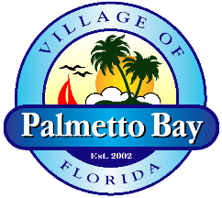

NOTICE OF UPCOMING TRAFFIC PATTERN CHANGES ON FRANJO ROAD FOR
“ROADWAY AND COMPLETE INFRASTRUCTURE IMPROVEMENTS (FRANJO ROAD PROJECT)”

The Franjo Road Project includes new roadways construction (178 St, 179 St and Park Drive) , roadways reconstruction (Franjo Road and 180 St), drainage lines, waterlines, sewer lines, hardscape, landscape, irrigation, undergrounding of utilities, state of the art light poles, sidewalks, bike lanes, signage and pavement markings. The next phase of this project requires a new traffic pattern beginning on February 5 of 2019 and includes the following key changes:

. Franjo Road to be closed from SW 184 St to SW 180 St (local traffic only).
. Detour route throught SW 180 St – SW 94th Ave – SW 184 St.

We understand that the construction activities will have an impact on your daily operations; however, we will try our best to solve any issues should we be notified in advance. Access will be always maintained to your home and business at all times during construction. Traffic impacts will be minimized as much as possible, however please plan for some delays and travel carefully through the work zone. Thank you for your patience during the construction period.
Please forward project related inquiries or questions to:

Public Involvement Officer
Shannan Ighodaro - 305-343-5006 - Esighodaro2@comcast.net

