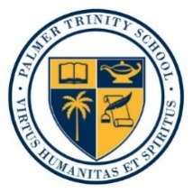
**Media Alert/Calendar Listing**

Palmer Trinity School Hosts Concert by
Grammy-Nominated Shelly Berg at Trinity Chapel
Free and Open to the General Public
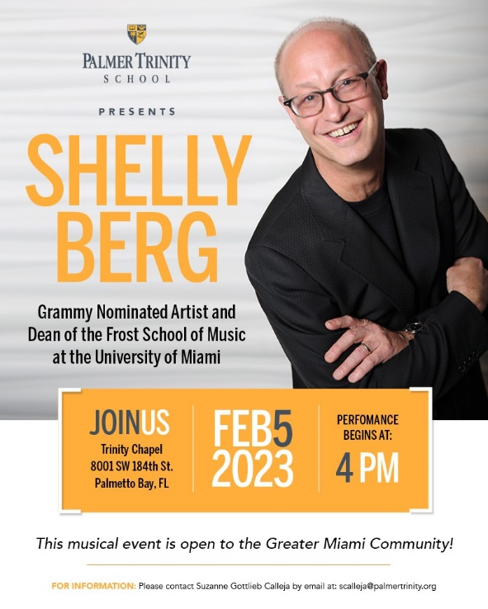
WHAT: On Sunday, February 5, 2023, Palmer Trinity School (PTS) is hosting a performance by five-time Grammy-nominated arranger, orchestrator and producer, Shelly Berg. The concert is free and open to the public. It will be the first professional concert held at the school’s Trinity Chapel.
Berg, dean and Patricia L. Frost professor of Music at the Frost School of Music at the University of Miami, will be inaugurating Trinity Chapel’s new Steinway piano with a concert of acclaimed jazz and classical numbers.
His recent projects include orchestrating, arranging and co-producing the Estefan Family Christmas, and performing with Tony Bennett, Patti Austin, Chris Botti, Steve Miller, Seal, Lizz Wright, Andra Day, Renée Fleming, and Arturo Sandoval. He has appeared as a performer and lecturer worldwide and is music director and an all-star musician for The Jazz Cruise, and artistic advisor for the Jazz Roots series at the Adrienne Arsht Center for the Performing Arts of Miami-Dade County.
WHEN: Sunday, February 5, 2023
4:00 p.m.

WHERE: Palmer Trinity School, Trinity Chapel
8001 SW 184TH Street
Miami, FL 33158

FREE AND OPEN TO THE GENERAL PUBLIC
On-site media contact:
Suzanne Calleja, Associate Head of School for Communications & Strategic Partnerships
(305) 401-8938

