֍ TSI’s Training & Personal Growth Workshops, 2017 ֎

Training Workshop

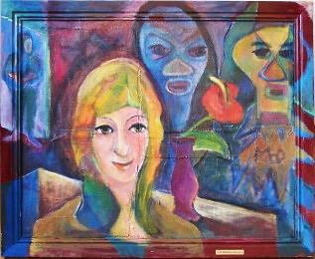
Making Friends With Your Defenses
January 13 - 15, 2017 ● Media, PA
Kate Hudgins, Ph.D., TEP & Action Healing Team
This workshop provides a simple description and an exciting action structure to help people identify defenses that are no longer useful in their current life. They can now begin to address residual trauma, as well as to open to fuller and more spontaneous lives. ﻿
- Time: Friday & Saturday, 10am-6pm; Sunday 10am-4pm
- Fee: $600; Early Discount: $550 in full by 12/13/2016
- Venue: Penn State University, Media, PA.
- Sponsor: Scott Giacomucci, Giacomucci & Walker, LLC.
- Ceu Information, Registration: www.SGiacomucci.com;
giacomucciscott@yahoo.com.
(Click here for full flyer)

֎ ֍ ֎ ֎ ֍ ֎

Media, PA
Friday & Saturday, February 3 & 4, 2017

Surviving Spirits: Healing Trauma and Addiction
When TSM first started in 1992, we called our personal growth workshops “Surviving Spirits” to honor the courage and determination of the women and men who participated in order to heal from sexual abuse. Since that time, TSM has gone around the world into 30 countries, learning more about trauma at both collective and individual levels, and expanding its work to include trauma at all levels.
We now re-introduce this TSM workshop with an emphasis on building the spontaneity and creativity needed to face trauma without the veil of addictions, including eating disorders. This is an introductory workshop for people on a personal journey of healing, who are ready to work in a like-minded community using action methods and expressive arts.
(Click here to view flyer.)

Sunday, February 5th
One-Day TSM Introduction Workshop

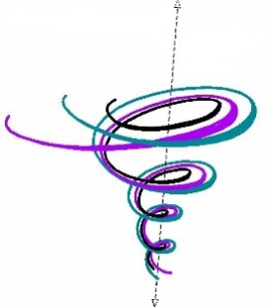
This one-day workshop introduces participants to the Therapeutic Spiral Model (TSM), which has been used by practitioners worldwide for over 25 years to treat the effects of trauma and addiction. Learn, through action demonstrations, skills-practice, and live supervision, how to build the spontaneity and creativity needed to face trauma safely and effectively with TSM’s clinically-modified methods of psychodrama.
Date & Time: Sunday, 2/5/17: 10am-6pm. Fee: $150. Venue: Penn State University, Media, PA. Sponsor: Giacomucci & Walker, LLC. Registration, Information: Scott Giacomucci: giacomucciscott@yahoo.com; www.SGiacomucci.com.

(Click here to view flyer.)

֎ ֍ ֎ ֎ ֍ ֎

Training Workshop

Collective and Individual Trauma Healing
March 3 - 5, 2017 ● Emeryville, CA
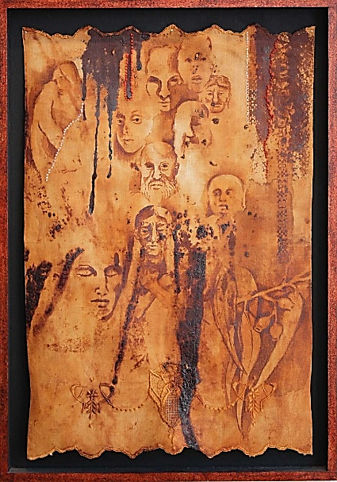
Kate Hudgins, Ph.D., TEP & Armand Volkas, MA, MFT, RDT
Participants explore the impact of trans-generational trauma on their identities by uncovering the dysfunctional narrative or “life script” they may be living as a member of the collective, beyond any conscious awareness.
Mixed with the collective experience are personal traumas, which seem to confirm dysfunctional beliefs about ourselves inherited from ancestors or their perpetrators. In our work together, personal and collective traumas rise up from deep explorations and ancestral investigations. We then apply the Therapeutic Spiral Model to address them safely.
Action methods include clinically-modified psychodrama, sociodrama, Playback Theatre, drama therapy and expressive arts therapy. Personal and professional growth is built into the workshop through self-exploration in a safe and contained environment.

• Time: 9:30am-5:30pm • Fee: $600 • Venue: The Living Arts Counseling Center, Emeryville, CA. • Hours for TSI International Program in Trauma Therapy; certification in Psychodrama, Sociometry, Group Psychotherapy; certification in Healing the Wounds of History approach; RDT through NADTA. • CEUs available: LMFT, LCSW, RDT, additional fee. • Info & Registration: Armand Volkas, 510-505-5500 x11;
armandvolkas@livingartscenter.org; info@livingartscenter.org﻿.

(Visit Armand’s website for more information.)

֎ ֍ ֎ ֎ ֍ ֎

TSI Training Workshop

Stop in The Name of Love:
Projective Identification in Relationships

March 10 - 12, 2017 ● San Rafael, CA
Kate Hudgins, Ph.D., TEP & Sylvia Israel, LMFT, RDT/BCT, TEP
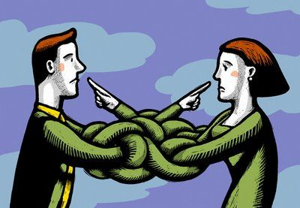
Projective identification (PI) operates in any relationship but is often misunderstood, especially when working with trauma survivors. Being a 2-way operation, PI’s are different than projections of transference and countertransference, and are crucial to recognize and integrate for healthy, functioning relationships and groups of any size. They are unconscious, i.e., an autonomic nervous system function, developed early to self-regulate feelings of distress and attachment. PI’s work well as survival responses, but create major disruptions in adult attachment and role reciprocity, especially when dealing with untreated trauma.
Learn how PI’s can hijack a group of trauma survivors and how TSM provides an alternative by creating the role of Appropriate Authority to prevent difficulties. Using your professional cases and personal work, you will practice the identification and integration of PIs in all relationships.
• ﻿Time: Friday, Saturday 10am-6pm; Sunday 10am-4pm.﻿ • Fee: $600. • Early Discount: $550, in full before February 10, 2017 • CEUs: MFT, LCSW, psychologists (Sylvia Israel #129230), ﻿ additional fee. • Registration/Information: Kate Hudgins﻿, drkatetsi@mac.com
(Upcoming flyer will have more data on workshop goals and CEUs.)

֎ ֍ ֎ ֎ ֍ ֎

Training Workshop

Finding Your Way Home﻿
March 18 & 19, 2017 ● Sunnyvale, CA
Kate Hudgins, Ph.D., TEP & Vlada Zapesotsky, M.A., PAT

In each of us beats a Truth that lives within our internal sacred space since the day we were created. It knows who we truly, naturally are and is waiting for us to hear its call and come back home--where we can be our own creators, healers, visionaries, directors, and guides.

Participants learn to activate and trust their soulful, inner GPS that shows the safe Way Home to the authentic self. The Helper Role of Housekeeper (TSM’s Observing Ego) neutrally brushes out the shame and blame of childhood traumas, abuses, and defenses that block the path. Action demonstrations, role play, and practicing TSM tools, help participants learn to apply psychodramatic methods that create a safe container and increase access to the inner world. Participants will also take the roles of director, client and auxiliary to experience their own healing, personally and professionally, along the way. This workshop is appropriate for all therapists, and students and practitioners of psychodrama.
• Time: Saturday & Sunday, 10-6pm • Fee: $500 • Venue: The Center of Healing, Releasing and Creativity: “The Way Home”, Sunnyvale, CA. • Information & Registration: Vlada Zapesotsky, Vladlenad@gmail.com
(See upcoming flyer for more data.)

֎ ֍ ֎ ֎ ֍ ֎

TSI Training Workshop
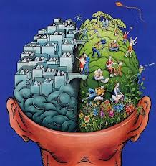
The Brain & Trauma: What works for Healing
March 31- April 2, 2017 ● Media, PA

Linda Ciotola, M.Ed., CET III, TEP,
Scott Giacomucci, LSW, CET II, TSI-AL,
& the TSI Action Healing Team

People who have experienced traumatic events can have significant changes in the neurobiology of their brain. The right brain holds emotions, relationship information, and unprocessed trauma, often in the form of flashbacks, body memories, intrusive thoughts and dissociated feelings. It is always turned on by an overactive amygdala. The left brain’s coherent function, which provides meaning to stay in the here and now, is interrupted by stress hormones as the result of danger signals from the amygdala.
Participants will learn to use the Body Double (BD) intervention to work with the energetic body and the ‘rhythmic rupture’ it suffers, along with the physical body and the brain, due to traumatic events. The brain-in-action along with attachment structures are taught through demonstration and live supervised practice and can be used immediately following the workshop in individual, couples and family therapy, as well as by educators and community organizers. This workshop expands the repertoire of students and practitioners of EMDR, EFT, sensory motor integration, as well as drama therapy and psychodrama.
- Time: Friday & Saturday, 10am-6pm, Sunday 10am-4pm
- Fee: $600, $100 deposit Early Discount: $550 in full by 2/18/2017
- Venue: Penn State University, Media, PA.
- Sponsor: Scott Giacomucci, Giacomucci & Walker, LLC.
- Ceu Information, Registration: www.SGiacomucci.com;
giacomucciscott@yahoo.com.
(Click here for full flyer)

֎ ֍ ֎ ֎ ֍ ֎

April 21st – 23rd, 2017 • Charlottesville, VA
Women’s Salon

A small group of 6-8 women meet at Kate’s home to share their stories, grieve their losses, and celebrate their true spontaneity and creativity in life. It is truly amazing and sad how much time and energy is spent in avoiding grief. This very pattern costs us living as our true selves—humans who can experience both moments of miracles and deep and searing loss.
This year’s theme for the Women’s Salons is to learn to let go so that we can make life safe enough to awaken the ‘sleeping child’ to the true potential to live life to the fullest.
- Fee: $600. Housing through solo or shared rooms at local hotels or Air BnB.
- Time: Friday, Saturday 10-6pm; Sunday 9-3pm.
- Venue: Dr. Kate's Home, where she cooks lunch for Sunday!
- Registration: Please apply to Kate: drkatetsi@mac.com.
(See upcoming flyer for more data.)

֎ ֍ ֎ ֎ ֍ ֎

ASGPP 75th Diamond Jubilee Anniversary Conference

May 4 - 7, 2017 ● Clearwater, FL
Kate and Monica Forst and a trained Action Healing Team present the pre-conference workshop: “What...You Think You Know TSM?” This is an opportunity to participate in and process a TSM drama that will focus on helping people gain the resilience and spontaneity needed to enjoy the conference in its fullness.
Venue: Clearwater Hilton: http://asgpp.org/conference2017.php

֎ ֍ ֎ ֎ ֍ ֎

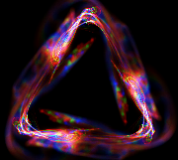
TSI Training Workshop
June 9 – 11, 2017 ● Media, PA
Transforming the Trauma Triangle
with
The Therapeutic Spiral Model

Monica Forst, M.Ed., C.C.C., I.C.A.D.C., R.P.
Scott Giacomucci, LSW, CET II, TSI-AL
& TSI Action Healing Team

The Therapeutic Spiral Model’s (TSM) unique “Trauma Triangle”, is a configuration that clarifies the destructive cycle of victim, perpetrator, and abandoning authority. In distinction to Karpman’s Triangle, this last role was created by TSM to explain the subtle, yet damaging, presence of someone who was absent—not there to rescue—i.e., there was no appropriate authority.
The Trauma Triangle represents a closed circuit of energy embedded in the personality structure of those who have survived cruelty or trauma, repeating itself as life-long patterns of abuse and neglect. This training provides tools that empower you to transform self-neglect to self-care and to instill healthy problem-solving into daily life.
Participants gain a deeper understanding of the internal personality and neurobiological structure of PTSD; learn to integrate TSM’s Prescriptive Roles & Safety Structures into clinical practice, and experience the power and depth of a TSM group process that is used across cultures.
This workshop offers training hours for CP in Psychodrama and can be used as a stand-alone course or as a foundation course for TSI’s Level 1, International Certification Program in Trauma Therapy.
- Time: Friday & Saturday, 10am-6pm; Sunday 10am-4pm
- Fee: $600; Early Discount: $550 in full by 5/9/2017
- Venue: Penn State University, Media, PA.
- Sponsor: Scott Giacomucci, Giacomucci & Walker, LLC.
- Ceu Information, Registration: www.SGiacomucci.com;
giacomucciscott@yahoo.com.
(See upcoming flyer for more data.)

֎ ֍ ֎ ֎ ֍ ֎

Residential Training Workshop ֍ West Chester
Wednesday, August 1st – Sunday, August 6th
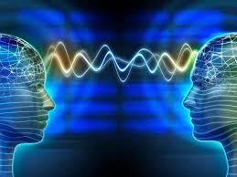
Directing Intensive:
Attachment and Trauma
Kate Hudgins, Ph.D., TEP
Monica Forst, M.Ed., CCC, ICADC, RP

As we learn more about the neurobiology of trauma, research on attachment is showing clearly how our brains interact. Comparing the 4 styles of attachment theory (secure, dismissive, fearful, and pre-occupied) with the 4-quadrant system of Transactional Analysis called the “okay corral”, we demonstrate how these patterns enhance or interrupt relationships. Participants learn in action to identify their preferred attachment style and how to use TSM to move toward a more secure self-attachment to feel safer in the world.
This Directing Intensive allows for personal work and the opportunity to practice TSM directing skills from the roles of trained auxiliary ego, assistant leader, and director. Those new to TSM will direct small vignettes and learn the TSM Safety Structures to bring self-regulation, attunement, connection, and spirituality to life.
Join us for this residential workshop that combines theory, practice, personal growth, and sociometry with like-minded people.
- Time: Wednesday, 8/1, 5PM – Sunday, 8/6, Noon
- Fee: $1200, tuition & housing.
- Venue: Retreat Center near West Chester, PA. TBA
- Sponsor: Giacomucci & Walker, LLC.
- Hours, CEU Information & Registration: Scott Giacomucci, giacomucciscott@yahoo.com; www.SGiacomucci.com
(Click here for full flyer)

