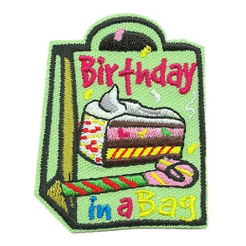
BIRTHDAY IN A BAG

Birthday in a Bag
- Large gift bag

- Cake mix
- Frosting
- Oil (small bottle)
- Aluminum baking tin
- Candles
- Cake decorations
- Birthday table cloth
- Forks
- Blank birthday card
- Small toy gift (ex. activity book and crayons)
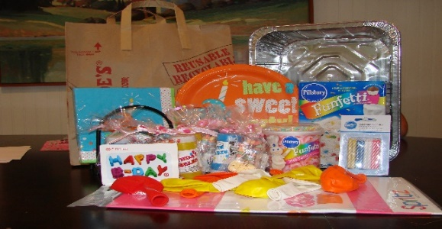

Instructions:
- Place each item in a large Zip lock bag.
- Create a note to the person receiving the package
-Made with care/Made just for you
-Made by (your first name or group info)
*DO NOT PUT ANY PERSONAL INFORMATION*
Any Questions Contact Christine Brown at cbrown@licares.org or (631) 582-3663 Ext. 120
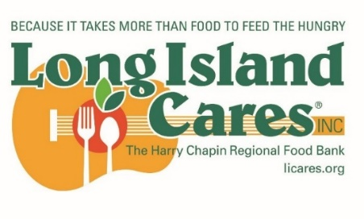
Long Island Cares Drop off Locations:
75 Davids Dr – Hauppauge – 11788
220 Broadway – Huntington Sta - 11746
286 W Montauk Highway – Hampton Bays – 11946
21 E. Sunrise Highway – Freeport -11520
386 N Wantagh Ave – Bethpage – 11714

