Shack Pack
Help support Long Island Cares Inc.
Hope For The Homeless
You collect, pack, decorate and seal and Long Island Cares will distribute your donations to a Long Islander in need!!
Earn 1 service hour per 4 bags

Supplies:
1 – Gallon Zip Lock Bag (Any clear bag that ties or zips)
2 – Bottles of water
2 – Ensure/protein drinks (any flavor)
2 – Protein bars
2 – Can of protein (must be pop-top)
1 -Tuna kit
1 - Toothbrush
1 - Toothpaste
1 - Deodorant (men’s or women’s)
1 – Bar of soap
1 – Washcloth
1 – Hand sanitizer

Directions: Add a personal touch with card or insert with a positive messages or pictures. Please make sure all items are shelf-stable and individually sealed

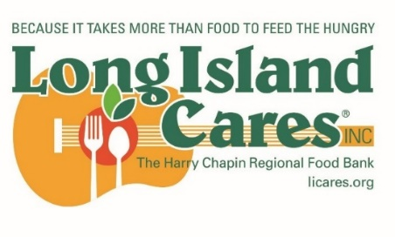
Long Island Cares Drop off Locations:
75 Davids Dr – Hauppauge – 11788
220 Broadway – Huntington Sta - 11746
286 W Montauk Highway – Hampton Bays – 11946
21 E. Sunrise Highway – Freeport -11520
386 N Wantagh Ave – Bethpage – 11714

