#### 

***In the Diocese of Palm Beach, we will celebrate Natural Family Planning***

***Awareness Week from July 25 through July 31, 2021, with the theme:***

***To Have, To Hold, To Honor in support of God’s gifts of love and life in marriage.***

***July 25, 1968 marked the day Humanae Vitae, a letter Pope Paul VI wrote to the world, was******released. Every year we celebrate his courageous vision for life and love on this date.***

NFP is 100% natural, it is 100% safe and has no health risks. Studies indicate that people who use NFP tend to be healthier, happier and closer to their spouses than those who use chemical birth control. For more information contact Cindy Fulmer in the Family Life Office.

*Couple to Couple League.

“Hormonal Contraceptives"

(February 2011)

**The Sympto-Thermal, Billings Ovulation, Marquette, and Family of the Americas Ovulation Methods are taught in classes throughout the Diocese. There are many options available, including learning with a mentor in a traditional classroom setting or at your own pace online. Both English and Spanish classes are available.**

**For more information please visit** [www.diocesepb.org/naturalfamilyplanning](https://nam11.safelinks.protection.outlook.com/?url=http%3A%2F%2Fwww.diocesepb.org%2Fnaturalfamilyplanning&data=04%7C01%7Cbzanotelli%40diocesepb.org%7C5554bb1c65ae4abd8a5c08d93a48129e%7C726f263cd39b4d81be448f5878e99e9b%7C0%7C0%7C637604903484794677%7CUnknown%7CTWFpbGZsb3d8eyJWIjoiMC4wLjAwMDAiLCJQIjoiV2luMzIiLCJBTiI6Ik1haWwiLCJXVCI6Mn0%3D%7C1000&sdata=9WhCiOrPh9%2FmV%2FwgFmBs1FLyy%2B9b136ouTAvQllyexk%3D&reserved=0) **or contact Cindy Fulmer, NFP Coordinator, 561-629-3889 or cfulmer@diocesepb.com.**

THE NUMBERS ARE IN—NFP IS EFFECTIVE!

Discover a natural way to postpone or achieve pregnancy. Modern methods of Natural Family Planning (NFP) have proven to be 99% effective in postponing pregnancy. NFP is also used with considerable success by couples trying to conceive – even when they’ve previously had difficulty achieving pregnancy.

Natural Family Planning is based on an awareness of a woman’s fertility. You’ll learn how to interpret certain signs of a woman’s body that indicate her fertile and infertile times.

The health benefits – physical, emotional, relational and spiritual – of practicing NFP are numerous. While contraceptives view your fertility as a disease, as something to suppress or treat, NFP respects your fertility as a gift and an integral part of the language your body speaks in marriage and love.

Did you know side effects of contraceptives include: increased in risk of breast cancer by 44% for women taking the Pill before her first child, increased risk of cervical and liver cancer, blood clots, stroke, heart attack, high blood pressure, headaches, decreased libido and cramping?*

“Love must be total, full, complete, governed by God’s law and it must carry into eternity.” St. Gianna Molla

**Diocese of Palm Beach**

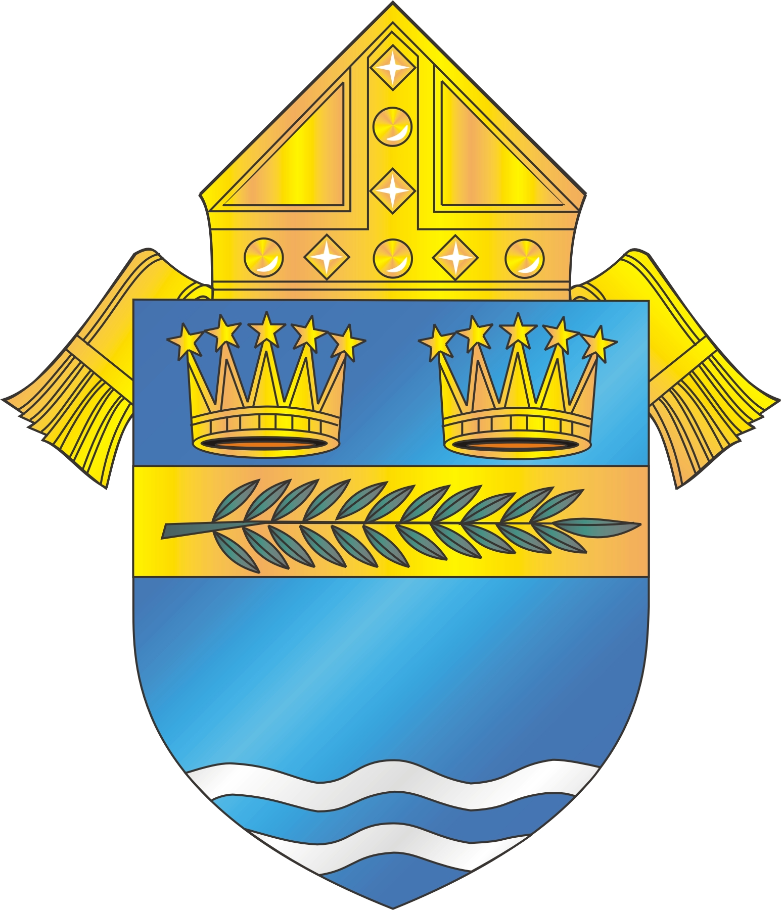

Celebrate Natural Family Planning Week

*in focus*