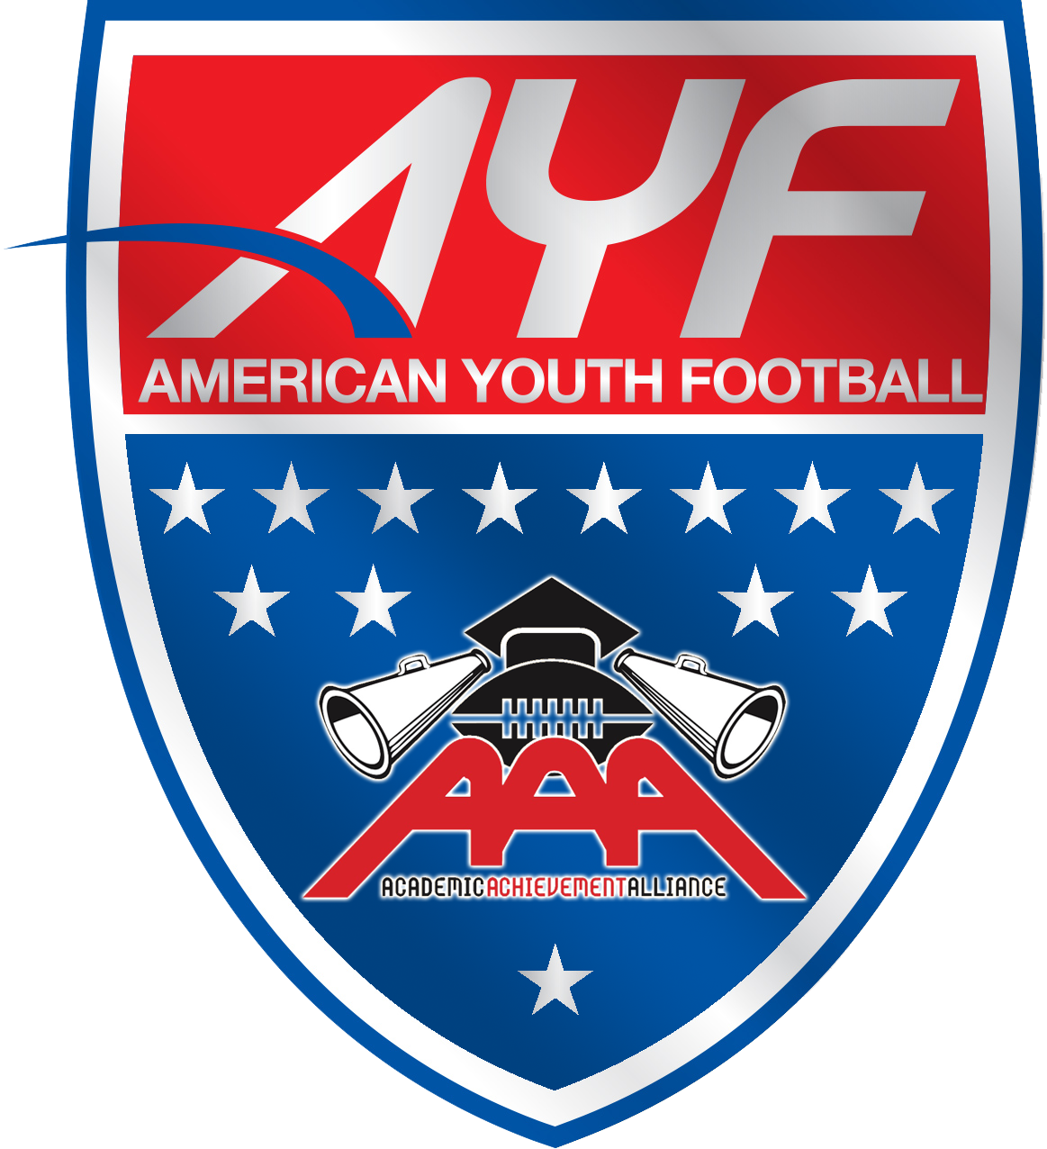

American Youth Football
Academic Achievement Alliance (AAA)

An alliance between AYF and member conferences to recognize
All-American Academic Achievement

American Youth Football and Cheer invites all players and cheerleaders to apply for the 2019 Academic Achievement Alliance (AAA).

All students with an average of 96% and higher will be considered for this honor. *(Please see page 3 of the application package for the grading conversion)

Please also be sure to include at least two extracurricular activities that do NOT include American Youth Football and Cheer.

The following are examples of extra-curricular activities that will be accepted:
- Religious Leadership roles
- Charity Work
- Community clean-up projects
- Recycling Programs
- Youth Programs I.e. Boys & Girls Club

Ensure that the application is completed in its entirety. Only applications that are submitted and filled out correctly will be considered for review by local association and league administrators.

DUE DATES:
Please submit your AAA application by the dates below to ensure proper review the application is for League/Association use only, AYF will not accept paper applications for AAA nominations, they must be done online after League/Association verification is performed:

- AAA applications due to your conference board by December 15th, 2020 for verification or an early date set forth by the local association or league.

- Association/League administrators MUST log-in to myayf.com and electronically submit all verified applicants with a 96% or Higher Average by February 1st, 2020. Paper Applications will not be accepted they are for Association/League Verification use only.

- AYF will announce all AAA award recipients in May 2020.

AAA recipients are chosen on the basis of academic achievement as well as extra-curricular activities and awards. All AAA recipients will receive a certificate to mark their achievement. A selection of exceptional students will receive a scholarship awards.

Please direct any and all questions about filling out this application please email services@americanyouthfootball.com

AYF/AYC Academic Achievement Alliance (AAA)
An alliance between AYF and Chartered leagues to recognize All-American Achievement

Only participants with a 96 percent or higher from the previous academic year are eligible to be considered for the AAA awards. All-American scoring is based on a candidate’s report card from the previous year and other involvement on page 2 of this application. Please submit all applications and report cards to the local associations/leagues for applicant verification, by November 15th, 2019 and then the association or conference must submit all verifiable AAA applicants electronically in myayf.com to AYF by February 1st, 2020.

PLEASE FILL OUT FORM COMPLETELY
First name * Last name * Student E-mail address
Name: *
Address:* |  |  |  | Phone: *
City: * |  |  | State: * |  | Zip: *
League Name: * |  |  |  | Football/Cheer: *
Assoc/Team Name: * |  |  |  | School Grade for 2018-19 Year:* (4th, 5th, 6th, 7th)

Contact:* |  | Phone:* |  | Email:*
* Indicates Required Information

Grading Conversions
To convert the student's grades, please use the attached Grading Conversion Scale. If a local proven local grade scale is used to convert grades, that scale can be used as long as sufficient proof of that scale is presented (I.e. listed on the report card, submitted in a letter from the school district, etc.). Convert all marks to numerical value (i.e., 100 percent). Round all figures to 2 decimal places.

Subject Areas and Averaging
- Language Arts (English, Foreign Languages, Reading, Writing, Grammar, etc.)
- Math (Arithmetic, Algebra, Geometry, General Math, etc.)
- Social Sciences (Social Studies, Civics, History, Geography, etc.)
- Sciences (General Science, Science, Biology, Chemistry, Computer Science, etc.)
- Humanities (Art, Music, Religion, Industrial Arts, Vocations Science, etc.)
- Physical Education, Health, Citizenship, etc

If the student took more than one course in a subject area, record the average grade with the number of courses in parenthesis. Example: English 92.20, French 93.50, and Reading 98 = 94.57 (3) in the Language Arts section.

Language | Math | Social | Science | Humanities | P.E | Grade
Arts | Math | Science | Science | Humanities | Health etc. | Average

AYF is not responsible for the inadequate or delinquent filing by any volunteer acting on behalf of a league, association, team, squad, or parent. Thorough review of all information is strongly recommended prior to submission at the local level.

We hereby attest to the authenticity of the information provided herein, and authorize AYF to contact person(s) noted if further information is deemed necessary.

Player’s Signature: __________________________________________ Date: ___________________

Parent’s Signature: __________________________________________ Date:___________________

Form must be signed by both Player and Parent for it to be considered for All-American consideration. Failing to sign this form will result in disqualification.

AAA All-American Nomination Package
In order to be considered for All-American candidacy A FULL YEAR’S REPORT CARD from your previous school year must be attached along with the application. All-American consideration is based on last year’s report card and involvement listed below.

Please complete Activities and Honors from THE PAST YEAR ONLY (2018-19 School Year). Please do not attach actual awards and honors to your application.

Student’s Name: ___________________________________________________________________

HONORS: (ex. Honor Roll, Honor Society, Specific School Awards, Gifted or AP Courses, etc.)

Honor: | _____________________________ | Contact: | _____________________________
 | _____________________________ | Phone: | _____________________________
Honor: | _____________________________ | Contact: | _____________________________
 | _____________________________ | Phone: | _____________________________
Honor: | _____________________________ | Contact: | _____________________________
 | _____________________________ | Phone: | _____________________________
Honor: | _____________________________ | Contact: | _____________________________
 | _____________________________ | Phone: | _____________________________

Extracurricular Activities/Community Service: (ex. Student Government, Publications, School Clubs, Band, Boy/Girl Scouts, Service Clubs, Sports Clubs/Teams, Community Service, etc.)

Activity: | _____________________________ | Contact: | _____________________________
 | _____________________________ | Phone: | _____________________________
Activity: | _____________________________ | Contact: | _____________________________
 | _____________________________ | Phone: | _____________________________
Activity: | _____________________________ | Contact: | _____________________________
 | _____________________________ | Phone: | _____________________________
Activity: | _____________________________ | Contact: | _____________________________
 | _____________________________ | Phone: | _____________________________

For AYF league/conference representative use only:
This form has been verified for accuracy and is applicable for nomination in the AYF AAA program by:
First name * Last name * E-mail address *
Name: *
League/Conference Name: * |  |  |  | Contact number:*
Signature:*

 |  | Grading Conversions to assess AAA if 100% Grade Scale is NOT used
 | 2-Point |  |  |  | 5 Point |  |  |  | 7 Point |  |  |  | 9 Point
 | Pass | 100 |  |  | A | 100 |  |  | E+ | 100 |  |  | E+ | 100
 | Fail | 59 |  |  | B | 89 |  |  | E | 93 |  |  | E | 95
 |  |  |  |  | C | 79 |  |  | E- | 86 |  |  | E- | 90
 | 3 Point |  |  |  | D | 69 |  |  | S+ | 79 |  |  | S+ | 85
 | S | + | 100 |  | F | 59 |  |  | S | 72 |  |  | S | 80
 | N |  | 86 |  |  |  |  |  | S- | 65 |  |  | S- | 75
 | U | - | 69 |  |  | 6 Point |  |  | U | 59 |  |  | U+ | 69
 |  |  |  |  |  | 6 | 100 |  |  |  |  |  | U | 64
 | 4 Point |  |  |  |  | 5 | 92 |  |  |  |  |  | U- | 59
 | Ep | Excel | O | 100 |  | 4 | 84
 | AP | Above | S | 88 |  | 3 | 75
 | MP | At Level | N | 76 |  | 2 | 67
 | UP | Not | U | 64 |  | 1 | 59
 | 10 Point |  |  |  | 12 Point |  |  |  | 13 Point
 | E+ | 100 |  |  | A | 100 |  |  | A+ | 100
 | E | 95 |  |  | A- | 93 |  |  | A | 96
 | E- | 91 |  |  | B+ | 89 |  |  | A- | 93
 | S+ | 86 |  |  | B | 86 |  |  | B+ | 89
 | S | 80 |  |  | B- | 83 |  |  | B | 86
 | S- | 77 |  |  | C+ | 79 |  |  | B- | 83
 | N+ | 72 |  |  | C | 76 |  |  | C+ | 79
 | N | 68 |  |  | C- | 73 |  |  | C | 76
 | N- | 63 |  |  | D+ | 69 |  |  | C- | 73
 | U | 59 |  |  | D | 66 |  |  | D+ | 69
 |  |  |  |  | D- | 63 |  |  | D | 66
 |  |  |  |  | F | 59 |  |  | D- | 63
 |  |  |  |  |  |  |  |  | F | 59

