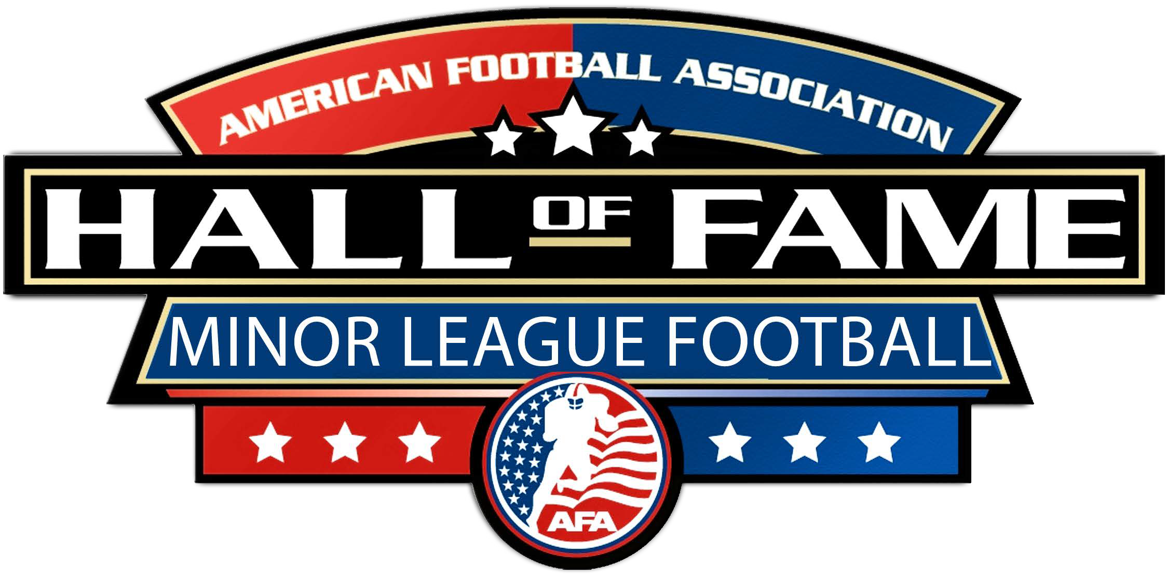

“Where Semi-Pro/Minor League Football Legends Live Forever”

P.O. BOX 2041 • BINGHAMTON, NY 13902 • Phone: (877) 624-4485 • Fax: (801) 838-0175
Website: www.AmericanFootballAssn.com E-Mail address: Amerfoot@aol.com

AMERICAN FOOTBALL ASSOCIATION 40th ANNUAL HALL OF FAME INDUCTION DINNER
Please consider supporting the AFA’s 40th Annual Hall of Fame Induction Dinner. The Dinner will be held on Friday, June 24th 2022 at the Pro Football Hall of Fame in Canton, OH. The Dinner Program Booklet will be 11"(h) by 8 ½"(w) size. In this information packet, you will find the Program Ad Sponsor Order Form attached for your use which includes ad sizes and cost breakdown. Our deadline for ads is April 30th. (Please email your camera-ready ad to (amerfoot@aol.com).
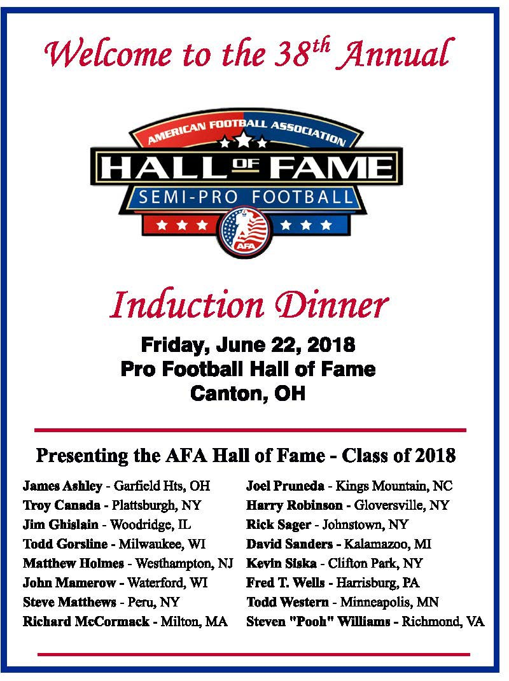
Thank you for your consideration and we hope that you will support this major event. I can be reached at 607-743-6013.

Sincerely,
David E. Burch - President American Football Association

AMERICAN FOOTBALL ASSOCIATION HALL OF FAME INDUCTION DINNER PROGRAM BOOKLET

MAJOR DINNER EVENT SPONSOR - BENEFITS Support Level: $5,000
- Name recognition to read: American Football Assn Hall of Fame Induction Dinner presented by (sponsor name)
- Name recognition on all announcements, marketing, promotions, TV & Radio ads, live webcast
- VIP Reception/Party Invitation "Meet & Greet" tickets (10) provided
- VIP Dinner Reserved Seating tickets (10) provided
- Recognized at the Dinner with speaking opportunity
- Head table banner (sponsor provided) at the Dinner
- Sponsor name on all Dinner tickets
- Full back cover ad on the Dinner Program that is distributed to all attendees (camera ready ad copy to be provided by sponsor)
- Full page editorial copy ad in the Dinner Program (provided by sponsor)
- Sponsor display booth in lobby prior to Dinner (provided by sponsor)
- Distribution of marketing literature or product sampling to dinner attendees

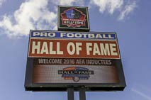
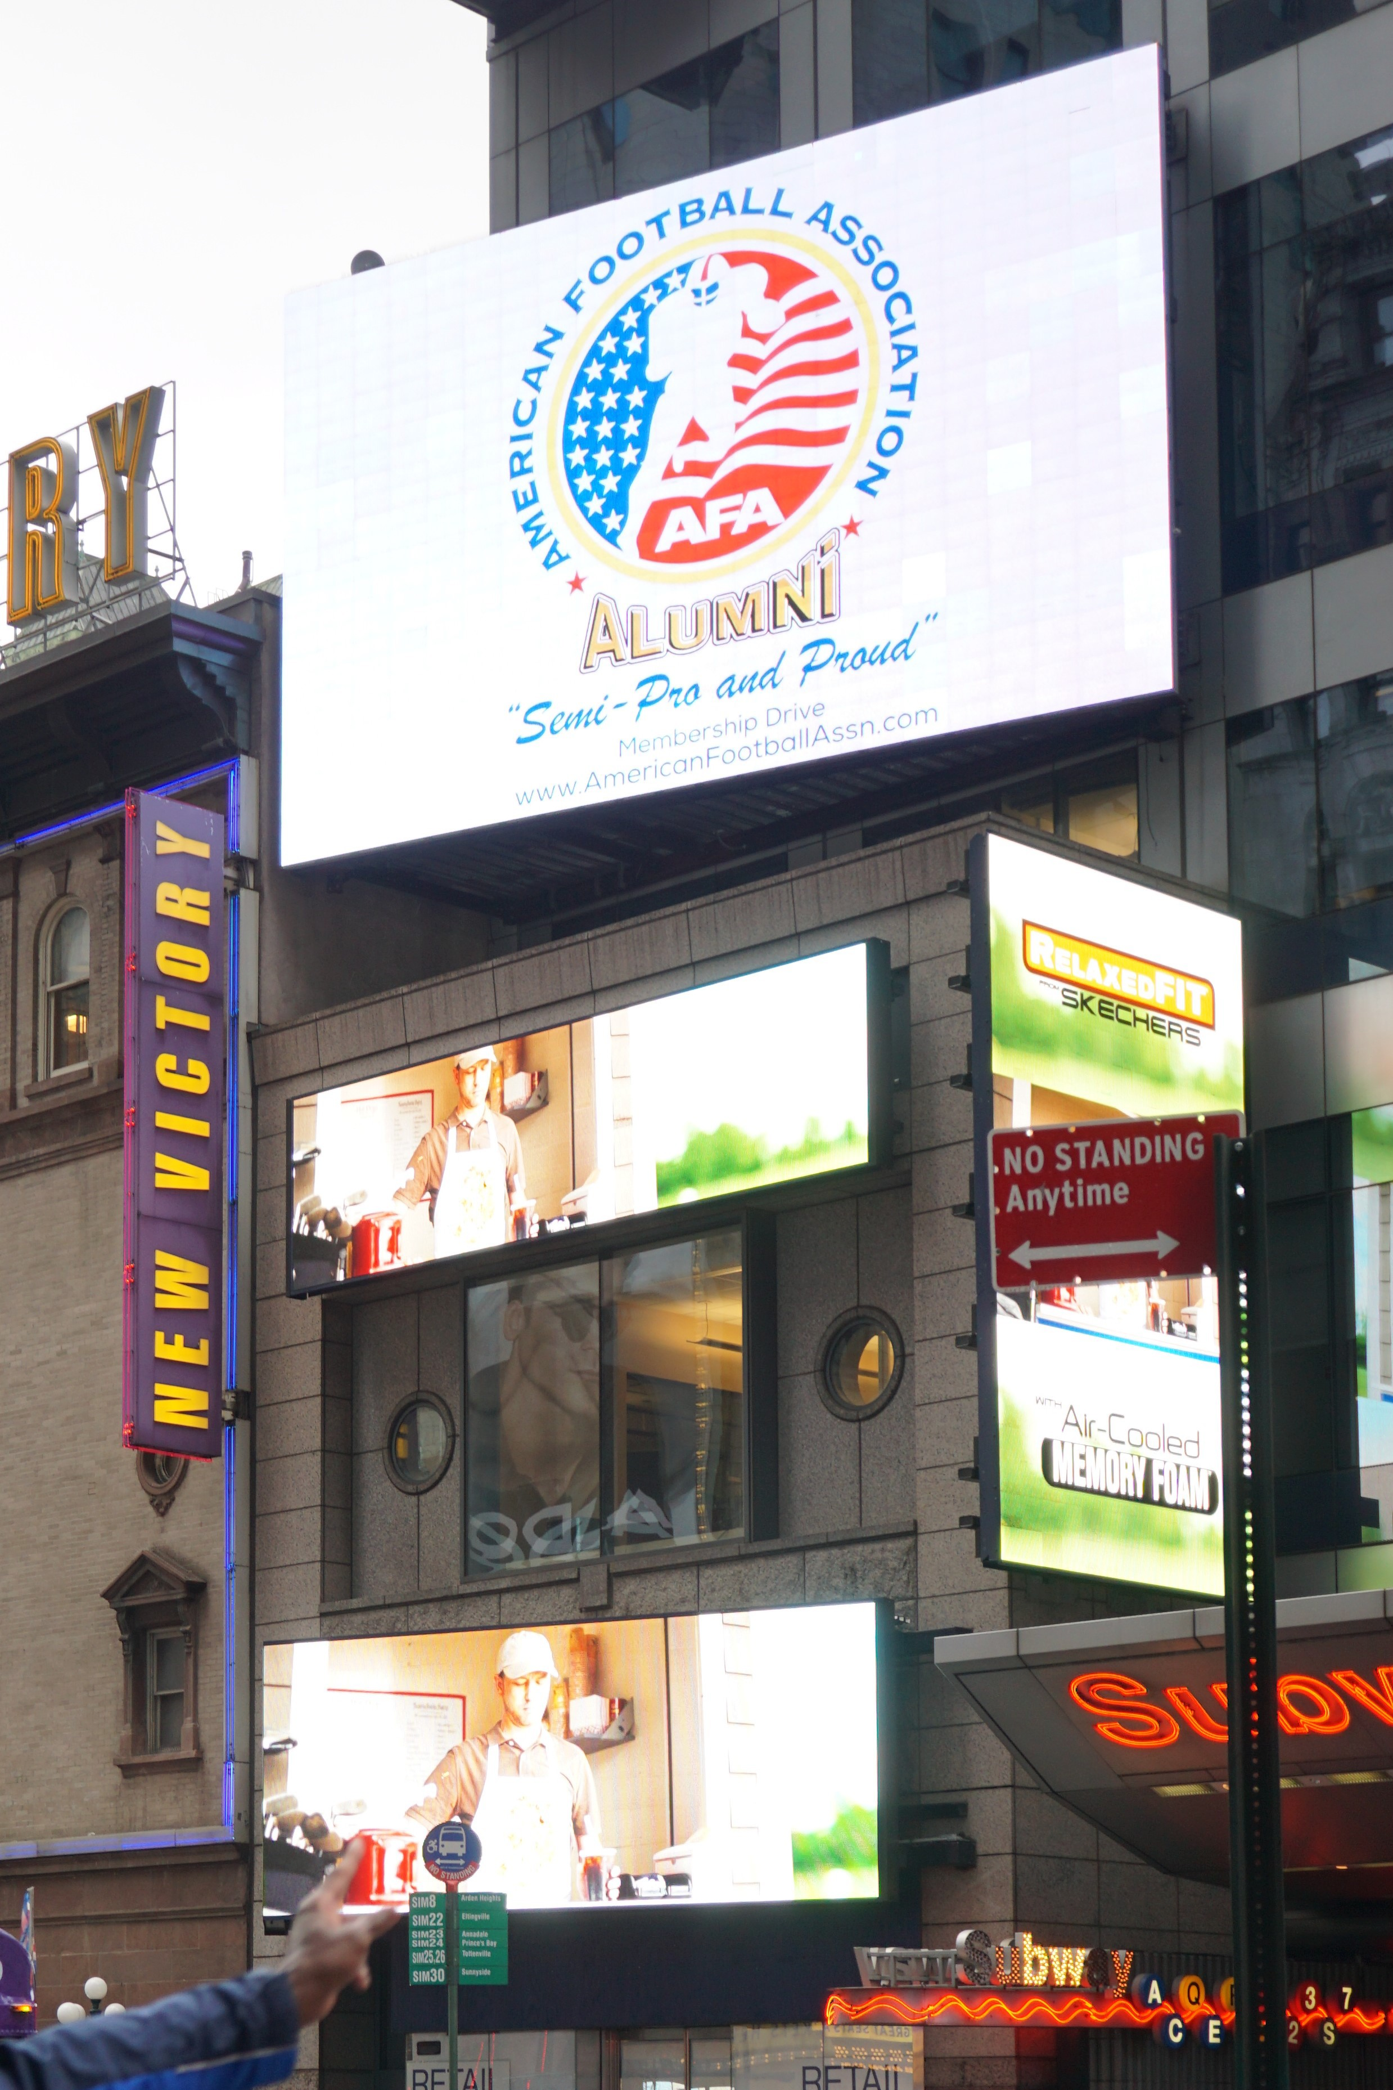
Name recognition on Pro Football Hall of Fame Marquis & Digital Billboard

- Acknowledgement Plaque

HOST SPONSOR OF THE VIP RECEPTION/PARTY - BENEFITS Support Level: $2,500
- Official Host Sponsor of the VIP Reception/Party
- Sponsor name recognition on all VIP Reception/Party Invitations
- VIP Reception/Party "Meet & Greet" tickets (8) provided
- VIP Dinner Reserved Seating tickets (8) provided
- Recognition by sign/banner (sponsor provided) at the HoF Dinner and acknowledgment by the Master of Ceremonies, live webcast
- Full page ad in the Dinner Program
- Sponsor display table in lobby prior to Dinner (provided by sponsor)

OFFICIAL INDUCTEE SPONSOR - BENEFITS Support Level: $1,000
- Official Individual American Football Assn Hall of Fame Induction Dinner Sponsor at the Dinner
- Recognition by sign/banner (sponsor provided) at the Dinner and acknowledgment by the Dinner Master of Ceremonies, live webcast
- VIP Reception/Party "Meet & Greet" tickets (4) provided
- VIP Dinner Reserved Seating tickets (4) provided One-Half page ad in the Dinner Program
- Sponsor display table in lobby prior to Dinner (provided by sponsor)
- Business Name (Logo) Recognition on Posters, Web Site, and Media Commercials, Live Webcast

OFFICIAL SPONSOR - BENEFITS Support Level: $500
- Recognition at the Dinner by acknowledgment from the Master of Ceremonies
- VIP "Meet & Greet" Reception Tickets (2) Provided
- VIP Dinner Reserved Seating tickets (2) Provided
- One-Half page ad in the Dinner Program
- Business Name (Logo) Recognition on Posters, Web Site, and Media Commercials, Live Webcast

If interested in any of the above sponsorship levels, please contact us at the following:
Contact: American Football Association
Email: amerfoot@aol.com
Voice: 607-743-6013; Fax: 801-838-0175

"AMERICAN FOOTBALL ASSOCIATION 40th ANNUAL INDUCTION DINNER" FRIDAY, JUNE 24TH 2022 (6:30pm) @ PRO FOOTBALL HALL OF FAME, CANTON, OH BOOKLET SPONSOR ORDER FORM

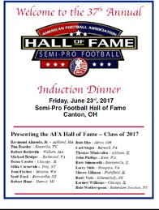

Payment - Paid:
Business Name: Address: |  | Contact Person: Signature:  Fax:  Email:
Ad Booklet Size (11"h by 8 ½"w)  Please circle size of requested Ad: |  | E-Mail Ad Copy to: amerfoot@aol.com  CAMERA READY COPY (BLACK & WHITE) ONLY  Ad Copy Deadline – MAY 1st  Ad To Read and Comments
Full Page (l0"h x 7 ½"w) | $500
½ Page (4 7/8"h x 7 ½"w) | $300
¼ Page (4 7/8"h x 3 5/8"w) | $150
Back Cover | $1000
Inside Front Cover | $800
Inside Back Cover | $600
Business Card Size | $100

Check#:

Please Make Checks Payable To: "American Football Association", PO Box 2041, Binghamton, NY 13902
Contact: American Football Association
Email: amerfoot@aol.com
Voice: 607-743-6013; Fax: 801-838-0175
Web Site: www.AmericanFootballAssn.com

