

A DIFFERENT SPIRIT
Creating Meaningful B’nai Mitzvah for Children with Disabilities
offers perspective and practical guidance
to help pre-teens with neural or physical challenges celebrate a joyful transition to Jewish adulthood

No one can overstate the courage it takes for a child with disabilities to confront the public milestone of b’nai mitzvah. A Different Spirit provides the support to start all considerations with “yes”.
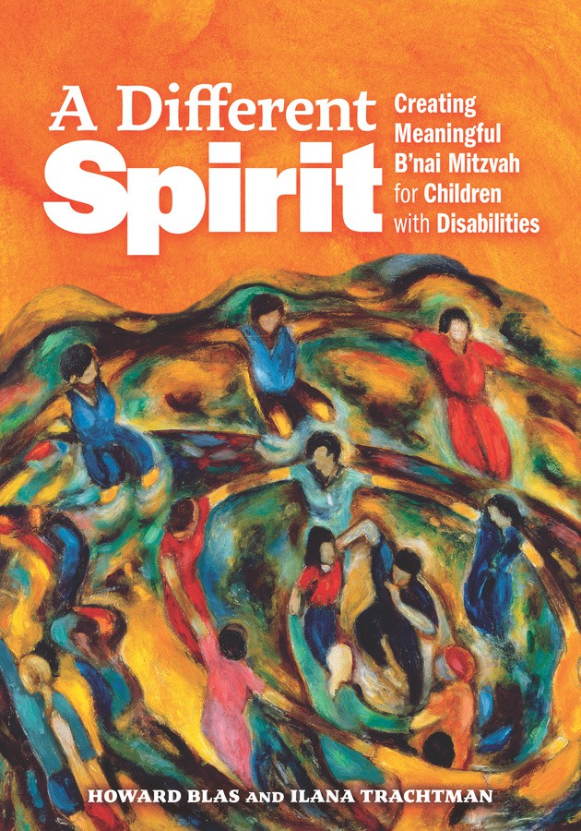
A Different Spirit is a collection written by experts from all over the world, including the most expert of all—people with lived experience of disability who share the story of their b’nai mitzvah, offering a compelling body of wisdom and encouragement that is utterly adaptable to individual needs.

In chapters organized not by disability but by challenges such as nonverbal, mobility, learning difference, vision, or hearing, contributors share strategies, techniques and reflections from the vantage point of each individual author.

Throughout, editors Howard Blas and Ilana Trachtman have sprinkled vignettes in sidebars as supplements, drawing from forty years of experience working with students , families, and clergy around b’nai mitzvah.

“Opens unimagined paths toward full spiritual inclusion and communal membership.”
--Andres Martin, MD, PhD, Riva Ariella Ritvo Professor, Yale School of Medicine

“A call to conscience, a wellspring of practical wisdom, and a celebration of every child’s sacred worth.”
--Rabbi Angela Buchdahl, Central Synagogue, New York City

“This immensely accessible, useful book is an invaluable resource.”
--Mark Oppenheimer, author of Thirteen and a Day: The Bar and Bat Mitzvah Across America

--more--

A Different Spirit is named for Caleb, the biblical character who is sent by Moses with eleven others to scout the Promised Land. Ten of the twelve returned with alarmist news, spreading fear that the land is unconquerable. Only Caleb and Joshua report the land’s beauty and that its challenges can be overcome, causing God to respond with praise, saying Caleb is ‘imbued with a different spirit’ (Numbers 13:30-14:24). We all have things to learn from children with ‘different spirits,’ who may show the way to a kinder, more interesting, and more inclusive world.

This book is for:
Parents, who will hear from other parents who have found the best way for their child, family, and community to mark b’nai mitzvah.
Clergy, who will discover real life examples of ways synagogues of all denominations have marked b’nai mitzvah for people with disabilities--from Shabbat morning in the main synagogue to celebrations on other days and in other venues. You will read personal stories of clergy who have disabilities themselves and children who have celebrated their milestone.
Educators, who will find tools for working with many learning styles and disabilities.
Students with a disability who might be nervous and unsure, who can learn how others in similar situations got through this process--and felt good about it.

Howard Blas is the director of the National Ramah Network, which provides inclusion and vocational training program support for young adults with disabilities in camps throughout the US and Canada. A social worker and special education teacher by training, he also teaches Jewish Studies and bar/bat mitzvah to students with a range of disabilities and special circumstances. He lives in New Haven, CT.

Ilana Trachtman is an Emmy award-winning creator of nonfiction programs for PBS, HBO, ABC-TV, Showtime, Lifetime, Discovery, A&E, and the Sundance Channel. Her independent film “Praying with Lior” received six Audience Awards for Best Documentary, the International Disability Film Festival Grand Prize, and was critic’s pick of The New York Times, Philadelphia Inquirer, and Washington Post. She lives in Philadelphia, PA.

A Different Spirit includes contributions from
Rabbi Menachem Creditor * Jacob Artson * Rebecca Redner * Arlene Remz * Rabbi Allison Berry
* Matan Koch * Dr. David Neufeld * Yishai Barth * Meredith Englander Polsky *
Rabbi Rebecca Schatz * Dr. Sheldon Horowitz * Daniella Bardack-Tarrab * Batya Sperling-Milner
* Rabbanit Aliza Sperling * Rabbi Darby Jaren Leigh * Serena Leigh Krombach *
Dr. Audra Kaplan * Jennifer Fink * Pamela Rae Schuller * Elaine Hall * Gabrielle Kaplan-Meyer * Rebecca Wannatick * Shelley Christenson * Dr. Stephen Shore * Jessica Leving Siegel

A Different Spirit is available widely, and as an ebook. Quantity discounts for congregations are available through Behrman House. Contact us through customersupport@behrmanhouse.com

2026PosesA

