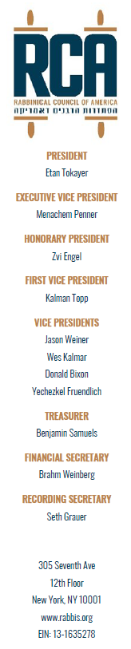
Dear Dear Mayor-Elect Mamdani,
I am writing to express my deep objection to your statement, communicated by your spokesperson, Dora Pekec, suggesting that Park East Synagogue “used a sacred space to promote activities in violation of international law.” This accusation is not only baseless; it is profoundly irresponsible and dangerous.

A synagogue is a place of prayer, community, and identity. To imply that such a space was misused simply because it hosted a Zionist program encouraging aliyah (immigration to Israel) - an age-old expression of Jewish peoplehood - is an insult to the Jewish community and a distortion of what actually occurred. Your insinuation maligns a respected religious institution and lends legitimacy to those who seek to intimidate Jews in their own houses of worship.

It is especially painful in this case because Park East’s rabbi is himself a Holocaust survivor. To see a synagogue led by someone who knows firsthand the most brutal consequences of antisemitism, accused of wrongdoing simply for encouraging a bond with Israel, compounds the hurt and trauma your words have already caused.

Even more troubling is the underlying message: that zionist yearnings that stir in the Jewish soul to immigrate to Israel, the world’s one and only Jewish state, is somehow suspect or inherently wrong. No other diaspora community is shamed or singled out for promoting ties to its ancient homeland. When Jews alone are told that connection to their ancestral home is a “violation,” that is not a political argument; it is an antisemitic trope dressed in modern language.

Your statement was issued in the wake of a protest that both targeted a synagogue and sought to instill fear in the Jewish community. At a moment when Jewish communities across New York are facing unprecedented hostility, your words did not calm the situation; they amplified the hostility. They give cover to those who believe it is acceptable to harass and intimidate Jews.

Your recent election seems to have emboldened the antisemites among us; witness the swastika desecrations hours after your victory, and your response to the Park East protest will most surely add fuel to that smoldering fire.

I urge you to reconsider your words, retract this harmful insinuation, and publicly make clear that Jewish religious institutions have every right to host programs connected to Israel, Zionism, and aliyah without being smeared, slandered or treated as suspect.
The Jewish community deserves better from its elected officials, especially now.

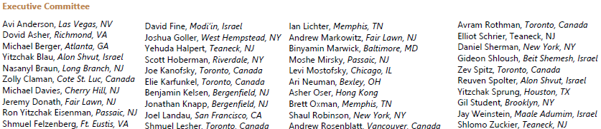
Sincerely,

