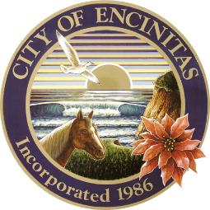
City of Encinitas
News Release

FOR IMMEDIATE RELEASE
Contact: Christie Goodsell, Recreation Center Manager, Encinitas Community & Senior Center
760-943-2251 or cgoodsell@encinitasca.gov

SENIOR CITIZEN SERVICE AWARD
Encinitas, CA, January 2, 2025 – The City of Encinitas Senior Citizen Commission, in partnership with the Encinitas Rotary Club, is pleased to announce that they will be honoring an Encinitas resident with the Senior Citizen Service Award.
The Senior Citizen Service Award recognizes a deserving senior citizen who demonstrates outstanding volunteerism, leadership, helping, teaching, mentoring, or advocating for others in the City of Encinitas. The award will be based on dedication, overarching commitment, and demonstrated impact of those served.
The Award recipient will be honored at a City Council meeting with a perpetual plaque housed at the Encinitas Senior Center. Additionally, they will be recognized as the guest of honor at an Encinitas Rotary Club meeting and invited to participate in the Encinitas Holiday Parade as a special guest of the Senior Citizen Commission.
Anyone may nominate a senior citizen by completing a nomination form and mailing it to the City of Encinitas, Senior Citizen of Year Award, Parks and Recreation Department, 505 South Vulcan Avenue, Encinitas, CA 92024 between January 9 and March 20, 2025, or by emailing it to PRCA@encinitasca.gov. Note: Mailed applications must be postmarked and emailed submissions must be received by 4pm on March 20, 2025. Nomination form, eligibility guidelines and additional details may be found at EncinitasCa.Gov/Recognition. (Senior Citizen Commissioners are not eligible to make a nomination.)
For more information regarding this award, please contact Christie Goodsell, City of Encinitas Recreation Center Manager at 760-943-2251 or cgoodsell@encinitasca.gov.
###
Located along six miles of Pacific Ocean coastline in northern San Diego County, Encinitas has an approximate population of 62,000 and is characterized by coastal beaches, flat-topped coastal areas, steep mesa bluffs and rolling hills. The city was incorporated in 1986, drawing together the communities of New Encinitas, Old Encinitas, Cardiff-by-the-Sea, Olivenhain and Leucadia.

