Filipino American Family
By John Michael Reyes, MDiv

In 2001, Filipinos all over the United States prepared for a movie of Filipino tradition meeting American culture: The Debut. The lead Filipino American actor, Dante Basco, famous for his role in Hook,evoked in me: kapwa, a shared connection. Surprisingly, for this budding liturgist, debuts
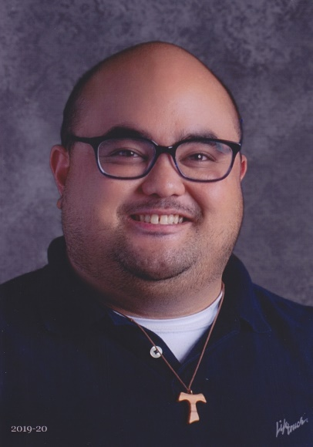
(Filipino coming of age celebrations) were foreign to me! Quinceañeras? Familiar! So, to hear of a Filipino version intrigued me because it gives rise to the spirit of camaraderie – bayanihan. As a second generation, Filipino American born in San Francisco, California, I have been formed by Filipino values while living as American. My parents tried to figure out what is normal in America while preserving Filipino values. Sewn together by the needle of faith, religious sensibility in Filipino culture is central. All this combined sorrow and joy: of how to make life work as a Filipino and an American. Alongside my blood father, my mother’s eldest brother was also a father figure to me.

A medical doctor who moved from the Philippines to Chicago, he eventually moved to San Francisco with my family and became a surrogate father, and guardian. He raised my younger sibling and me, while my dad and mom worked hard creating a life in America. My experiences of living American values were influenced by Filipino ones and vice versa. During my first year in college, my uncle suffered from not one, but a series of strokes in a month’s time which left him semi-paralyzed with a speech impediment, and ultimately, homebound. The doctor who took care of my childhood injuries and tears became the one who cried and could not speak. A few years later, my maternal grandmother would visit America, eventually live with us, but then get ill and die in America. “Finish your schooling,” my late lola (grandmother) would say, “…and then you can do whatever you want.” Well, not really.

In Filipino, Utang-na-loob means “debt of gratitude” and pakikisama, “maintaining harmony.”
These two values were braided into one as discerned which college to attend. While the colleges I desired were far away, the obligation to family and staying close to home made my discernment lists moot. Even after obtaining a master’s degree and moving for a dream job at Seattle, Washington, something beckoned me back home. Through all this, as I fulfilled my obligations as the eldest Filipino son, I was called “good,” and I attribute this to the role of my faith and my love for family.

While the American ideal is for children to “move out” and make a life for themselves, a Filipino ideal is for families to stay together, for children not to leave their parents’ house until they get married – and even then, to bring in their parents into their own home to take care of them in their later years. Multigenerational families are a norm in Filipino households, with children obliged to show affection for older family members. As my experience illustrates, many Filipino young adults struggle to balance what it means to honor family, alongside how to “adult” today.

I learned every day the joys and sorrows of living with aging and disabled family members. Instead of considering a retirement home for my uncle, I learned the value of solidarity and relied on the image of the Holy Family to give me strength in living within a multigenerational house. My faith was strengthened in seeing my uncle grow in his faith, becoming a strong and devoted prayer. Sadly, my uncle unexpectedly passed away December 1, 2020.

Filipinos understand that they would not be without those who came before them, so they work hard to make their families proud. To forget and leave behind those who have brought them here is to disrespect family and culture. With the Filipino value of hiya – not bringing “shame” for personal gain – hanging over our heads, everything must be decided with the family in mind. I have learned gratitude through action because of my mother's care for her brother, and I hope that I can instill in others that commitment to service.

My extended family brings me much joy (and, yes, woe!) and continually aids in my own discipleship to “consciously and freely seek the living God...” (RCIA, 1). One lifegiving thing for Filipino American young adults is that the bonds of family are not constrained to blood relatives; anyone can be a cousin, an aunt, etc. This aligns with the Catholic imagination of claiming the “dignity of adopted children ... indeed the children of God” (RCIA, xiv). From communal occasions like Simbang Gabi, - the 9-day Advent Novena before Christmas to giggling whenever I hear an elder exclaim, “Susmaryosep,” (a contraction of the names of Jesus, Mary and Joseph), my identity is continually revealed through the Body of Christ, in all its diversity.

I wonder if other Asian, Pacific Islander young adults share similar values? Alternatively, do any values cause resentment? May we boldly embrace and celebrate our many cultures, to recognize the commonalities we have, and to worship the One who - by becoming flesh - “debuted” for the life of the world.

____________________________________________________________________________________________________

- Name: John Michael Briones Reyes, MDiv
- Birthday: September 11, 1987
- Geographical location: San Francisco, California
- Cultural family: Asian Pacific Islander (Filipino American)
- Role: Young Adult, Ministerial Leader
- Parish: Most Holy Redeemer, San Francisco, CA
- Employment: Sacred Heart Schools, Atherton (Role: All Schools’ Director of Prayer and Worship (PSK - 12th Grade)
- Organization: TeamRCIA

