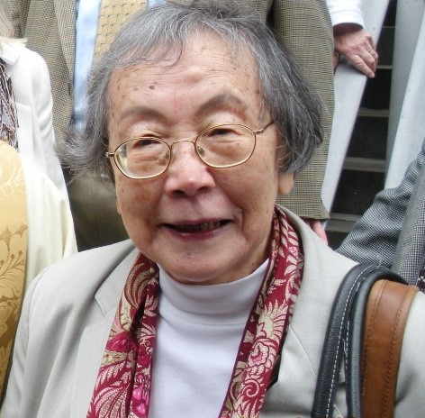
Remembering Dr. Ruth Narita Doyle

Dr. Ruth Narita Doyle, the first president of the Asian and Pacific Catholic Network (APCN), passed away peacefully at her home in Riverdale, NY, on December 31, 2020, at the age of 93.

After beginning her professional life working in research at the Episcopal Center in New York, she then went on to head the Research and Planning Department at the Catholic Archdiocese of New York, under three different Cardinals. She was the editor of Clergy Report, served on the Archdiocesan Pastoral Council, the Asian/ Pacific Islander Committee and conducted two massive research projects on behalf of minority communities in New York. In the meantime, she got her PhD at the age of 64, was a research scholar at Fordham University in the Department of Sociology and Anthropology and taught graduate classes. She also learned Spanish. Over the years, she was methodical and focused using her expertise in applied research for information gathering and analysis to serve the research needs of decision makers in the Church and to advance scholarly research on Catholicism. She was active in multicultural ministry at the parochial, diocesan, and national levels.

Dr. Doyle was a member of the team that assisted the bishops’ committee in drafting the pastoral statement by the United States Conference of Catholic Bishops (USCCB) entitled Asian and Pacific Presence: Harmony in Faith (2001) and continued to help guide, manage, or organize several national pastoral institutes, national gatherings, learning seminars, listening sessions, and a national summit in 2006. For her work on behalf of Asian and Pacific Islander Catholics, she was recognized by the Center for Applied Research in the Apostolate, Washington, DC, with an award for exceptional service.

Dr. Doyle was one of the founders of the National Asian and Pacific Catholic Organization and helped organize the first national Asian and Pacific Catholic Convocation in 2006 in Arlington, VA. She strongly believed in the important role the laity can play to effect lasting change. To do that she relentlessly promoted opportunities for formation, for appreciation and understanding, and studies on the implications of diversity on the ecclesiology of the U.S. Church. She organized skill-building workshops to promote inter-cultural dialogue and collaboration. As a scholar, mentor, and educator she was very successful in highlighting the need for multicultural representation in the Catholic Church. Prior to the reorganization of the USCCB when the Pastoral Care for Migrants and Refugees (PCMR) was under the department of Migrants and Refugee Services (MRS) until the transition of the PCMR to the Secretariat of Cultural Diversity in the Church, Dr. Doyle organized bi-annual Asian and Pacific Institutes for Mission and Ministry in the U.S. Catholic Church from 2003 until 2009, held alternately at Fordham University, NY and Catholic University of America, Washington, DC.

As first President and one of the founders of Asian and Pacific Catholic Network (APCN), Dr. Doyle helped draft its By-laws and Constitution. She was a huge supporter of the APCN annual Marian Pilgrimage at the Basilica of the National Shrine of the Immaculate Conception in Washington, DC, which she attended every year. She advertised the Pilgrimage in New York and made sure she participated in person – sometimes travelling alone or often bringing with her a large group of pilgrims. For over 20 years, Dr. Doyle actively participated in the annual Catholic Social Ministry Gathering organized by the USCCB’s Department of Justice, Peace, and Human Development each February in Washington, DC, even when travel into and out of the city would be temporarily suspended due to a blizzard.

Dr. Doyle was preceded in death by her husband of 60 years – Steve, and her son Michael. She leaves behind her daughter Elizabeth, her son Peter, her grandchildren Sam, Kylee, and Sarah and their families to mourn her passing. She will be remembered by the numerous friends, clergy, colleagues, API Catholics, and former students all over the U.S. with whom she freely shared her knowledge and expertise. She was a pioneer in her emphasis on the importance of multicultural representation in church ministry, and her dedication, hard work, determination, focus, and methodology will always be remembered. She volunteered her time and her expertise selflessly over several decades. May her soul rest in eternal peace. Amen.

By: The Asian Pacific Catholic Network (APCN) pastoral leaders

