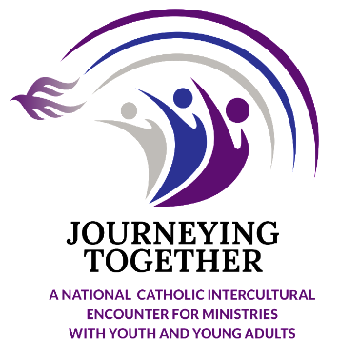

Saturday, March 6, 2021
3-5 PM ET
Virtual Gathering
Call to Prayer

Sounding of the conch
Traditional Hawaiian oli pale chant

Noho ka Makua Mana loa  Noho ka Makua Mana loa i loko  Okakou ike ‘ia i ke Keiki ‘o Iesu  Me ka ‘Uhane Hemolele, e malu e  Hoe e ho’oulu mai ia makou i  Ho’olokahi ‘ia i ke aloha, i ka ‘oli  O ko alo e | Translation  God the Father Almighty is among us  He has been seen in his Son, Jesus  With the Holy Spirit, guide and protect us  Help us to grow, we who have been gathered, in the love, in the joy of your presence.

Call to Prayer, oli pale, Noho ka Makua Mana loa, traditional Hawaiian chant, Dietrix Jon Ulukoa Duhaylonsod, 2020, HI. Used by permission. In the video with Ulokoa are Lopati James, Vito James, Etuale James, and Kama'ehuahunui Maria (blowing the conch).

