**How to Call your Representatives to Support Funding for the Institute of Child Nutrition**

**Step 1: Find Your Elected Officials**

Go to <https://www.congress.gov/members/find-your-member> and enter your zip code or address to search for your House Representative and State Senators.

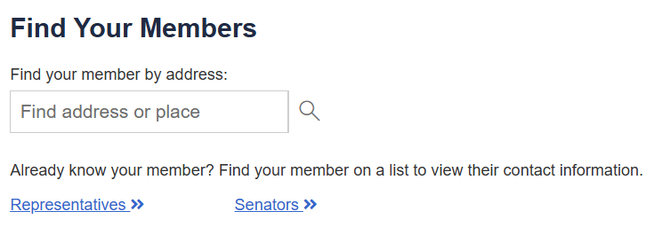

**Step 2: Call Your Elected Officials**

Hello. My name is [**YOUR NAME**], and I am a constituent of [**SENATOR/REPRESENTATIVE’S NAME**] living in [**CITY/TOWN AND STATE**].

I’m calling because I’m concerned about possible funding cuts for the Institute of Child Nutrition (ICN).

The Institute of Child Nutrition provides vital resources, workforce development, and program operations support for federally funded child nutrition programs that serve meals and snacks to almost 30 million children in 94,000 schools across the nation every day, including our own state.

Funding for the Institute of Child Nutrition is necessary to ensure school nutrition programs at the state and local levels continue to have access to the training, technical assistance, and resources they need to meet federal requirements for school nutrition professionals.

Please oppose any cuts to the Institute of Child Nutrition funding and support funding increases for ICN when it comes up for a vote this legislative session.

Thank you.