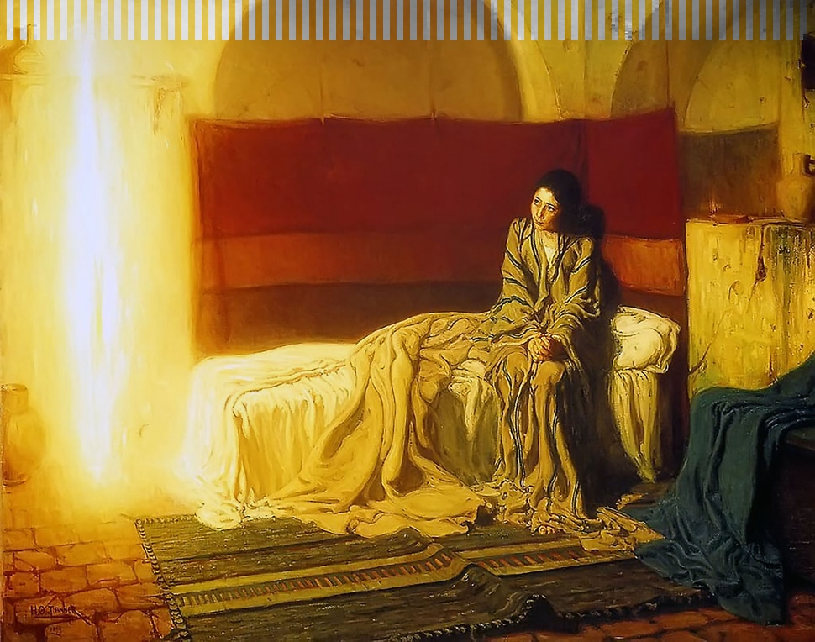
The Annunciation by Henry Ossawa Tanner

Close Encounters with the Divine

A Listening Hearts Ministries Retreat, Maryland Episcopal Diocesan Center, Baltimore.

Saturday, November 1, 10:00 a.m.–2:00. p.m.
Have you had a memorable religious or spiritual experience and continue to wonder about it? Have you thought about why it occurred when it did and what meaning it held for you? Did it change the way you think and live? A Pew Research Center survey in 2023 found that almost half of U.S. adults (45%) report having had a sudden feeling of connection with something from beyond this world, while 30% say they have personally encountered a spirit or unseen spiritual force. And yet, many people are reluctant to talk about their experience for various reasons.
If you would like to share your experience with others, and hear others’ stories in a friendly, engaging atmosphere, we invite you to register for our FREE retreat at the Maryland Episcopal Diocesan Center, 4 East University Parkway, Baltimore, MD, 21218, on All Saints Day, November 1. Listening Hearts will provide lunch and snacks, again at no cost to you.
Please note: if you don’t wish to share your experience, or have not had one, you are still welcome to come! We would love to have you with us to listen and learn.
Click HERE to register by sending an email accepting our invitation to the Listening Hearts office, listening@listeninghearts.org. Be sure to include your name and phone number. Thank you!

