Greetings in Jesus’ name.
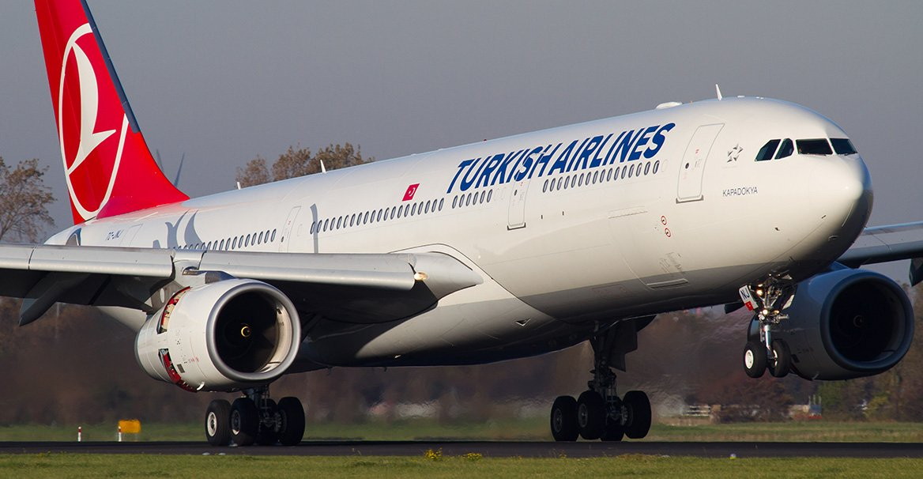
Beloved in the Lord Jesus, you are invited to join me (on my 24th tour), a native of Israel, born in Nazareth on a Journey to the Holy Land–Israel for an experience of a lifetime We will depart from Chicago on August 15 and return on August 27, 2022...walk where Jesus walked...where every page of the Bible is seen in its original context alive...cruise the Sea of Galilee...climb the Mount of Olives and view the Old City of Jerusalem...visit Tabgha, scene of the Miracle of the Loaves and Fishes...the Mount of Beatitudes, site of the Sermon on the Mount and where Jesus chose His Twelve Apostles...walk the Via Dolorosa (Road of Suffering) to the Church of the Holy Sepulcher...stroll in the Garden of Gethsemane...visit Bethlehem...the Church of the Nativity and much more

What to expect: During this 13-day tour, you will experience the sounds, smells and sights of two civilizations the old and the new. You will stand at the cross roads of history and feel the vibrant influence of how this land shapes all other lands.

We will do more than just visit sights. We will go off the beaten path and have personal and daily devotions. The Bible will be our map and guide. Experience the Holy Land–a place like no other. Please join me on this blessed adventure

The price is $4, 000.00 or $4, 300.00 p/p includes: air fare from Chicago or Minneapolis to Tel Aviv and back to Minneapolis and or Chicago, hotel accommodations (for double occupancy) tips, entry fees and all meals.

For further information contact:
Pastor Nabil Nour
46448 263rd St.
Hartford, SD 57033
605-526-3571 (O)
605-201-6998 (Cell)
preachermanfootwasher@gmail.com
