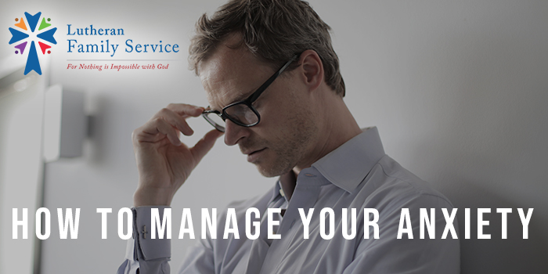

November 30, 2021
How to Manage Your Anxiety
I experienced dark times in my life as a child and at every stage of my growth into and through adulthood. I became a prisoner of my anxiety; especially in my earlier years.
I was gripped by obsessive thoughts and worries; phobias (in my case excessive handwashing to ward off germs); inability to slow my thoughts and worries which interfered with my concentration and sleep; ritualistic behaviors that I thought were necessary to fend off terrible things happening; and intrusive thoughts of frightening situations that had actually occurred in my life. These symptoms did not happen all at once. They were strung out over time and abated to just a very few occurrences in my mid-thirties.
Anxiety shows itself in all of these ways and more. Diagnostically, anxiety disorders include Generalized Anxiety Disorder, Post Traumatic Stress Disorder (PTSD), Phobias, Obsessive Compulsive Disorder (OCD), Panic Disorder, and Social Anxiety Disorder. When we experience anxiety in a manner that interferes with our daily functioning, it is time to take a look at how to manage this condition.
The ADAA-- Anxiety & Depression Association of America reported (adaa.org/understanding-anxiety/facts-statistics):
- Anxiety disorders are the most common mental illness in the U.S. affecting 40 million adults aged 18 and older or 18% of the population every year.
- Anxiety disorders are highly treatable, yet only 37% of those suffering receive treatment.
- People with an anxiety disorder are three to five times more likely to go to the doctor and six times more likely to be hospitalized for psychiatric disorders than those who do not suffer from anxiety disorders.
- Anxiety disorders develop from a complex set of risk factors including genetics, brain chemistry, personality, and life events.
Managing the physical aspects of anxiety along with the cognitive processes that feed anxiety can be extremely helpful to improve daily functioning and quality of life.
Managing Anxiety Physically
When anxious, our body responds in “fight or flight” fashion. We physiologically prepare for battle, though there is no physical battle to fight. Our breathing becomes shallow and rapid, our muscles tense, our heartrate increases, we may perspire, we may experience stomach aches, weakness, headache, and shakiness. The more we notice these effects, the more anxious we become, sometimes believing that we may be having a heart attack. While it is essential that we take potential heart attack symptoms seriously, once we have determined that is not happening. it is time to look at how to manage these symptoms.
The best way to prepare for physically reducing the effects of anxiety is to practice relaxation techniques to the degree that we can utilize them when the signs of anxiety begin to develop. Our body cannot respond in an anxious way if we are relaxed. Practicing progressive muscle relaxation and deep breathing exercises are very effective techniques for this. Progressive muscle relaxation is purposely tensing, then relaxing muscle groups moving from toes to head. Deep breathing exercise is purposely breathing from the diaphragm rather than shallow chest breathing and monitoring inhaling and exhaling to slow down respirations. A great resource for this is YouTube which can provide hundreds of guided exercises that will address breathing and muscle relaxation. Peruse what is there and find the ones that work best for you.
Here are two video links to show you examples of progressive muscle relaxation and deep breathing:
- Progressive muscle relaxation: https://www.youtube.com/watch?v=ClqPtWzozXs
- Deep breathing: https://youtu.be/Wemm-i6XHr8.
These videos give you a general idea of what you are looking for. However, it might be more beneficial to search for videos that have the voice and background music that feels best suited to you. To utilize these techniques when you need them most, you will need to PRACTICE! Practice before you are in a state of high anxiety so that when you have to use these tools, you are familiar with the technique, and you know it works.
Managing Anxiety Cognitively
The cognitive portion of managing anxiety involves talking rationally and reasonably to yourself. This is where my “go-to” Bible verse comes in.
“Do not be anxious about anything, but in every situation, by prayer and petition, with thanksgiving, present your requests to God. And the peace of God, which transcends all understanding, will guard your hearts and your minds in Christ Jesus.” Philippians 4:6-7
This verse was not in my repertoire when I was younger, but now that my faith has developed and strengthened, it provides me with immediate reassurance. God tells us not to worry. He tells us to come to Him. We can be assured that He will handle our situation in the way He deems fit. We do our personal part, but what we can’t control, we have to work at not trying to do so.
At a time when my children were high school age, my husband’s job of 33 years ended due to reorganization of the company. I was working part-time as I wanted the freedom to be involved in my children’s lives while they were at home. With the loss of his job, came the loss of insurance benefits. I was able to access insurance through my work, but the cost took most of my part-time paycheck. My husband went almost a year without steady employment despite a wide search. The fact that he was in his mid-fifties probably played a role.
As I pondered the situation, there was so little we had control over in terms of his finding another job. It was possible we might not be able to pay bills, might lose our home, might even struggle with putting food on the table. As I thought of those things as the worst possible scenarios, I had a sense of peace that wafted over me. That was the peace of God’s promise. If all those worst possible things happened, I was certain that God would take care of us as He always has. The most important part, that we stay together as a family, didn’t hinge on whether we had our own home. We could manage a life anywhere, as long as we were together.
I look at many situations that create anxiety for me now with that perspective; that God has a plan for my life. He will provide for me and my family. And, when I’m anxious, it means that I’m forgetting God’s promise and is a reminder that I need to return to it. The Bible is filled with these promises. Perhaps several bible verses are coming to you that may help you remember His promises. If not, do an internet search for “bible verses for anxiety and depression,” and you will find a plethora of reminders that God has us in the palm of His hand.
Take a look at what you are telling yourself about the situation that is creating anxiety. Challenge the negative thoughts and the “ain’t it awful” thinking. Replace those thoughts with the promise of scripture. Replace those thoughts with a rational perspective that you might offer a friend who you are trying to reassure or comfort. Our thoughts dictate our emotions. If we can alter what we are thinking about our situation, we can alter our emotional reaction, including anxiety. Pairing this type of thinking with the physical tools of progressive muscle relaxation and deep breathing is a powerful and positive response to combatting anxious feelings.
There is a time when you may need professional help coping with anxiety. Our counselors are experienced, Masters-level prepared Christian therapists that are equipped to assist from a practical and spiritual perspective. Learn more about mental health counseling or reach out at https://lutheranfamilyservice.org/mental-health-counseling/
Toni Larson, LISW
Director of Counseling
Lutheran Family Service

