Twain House Annual Meeting

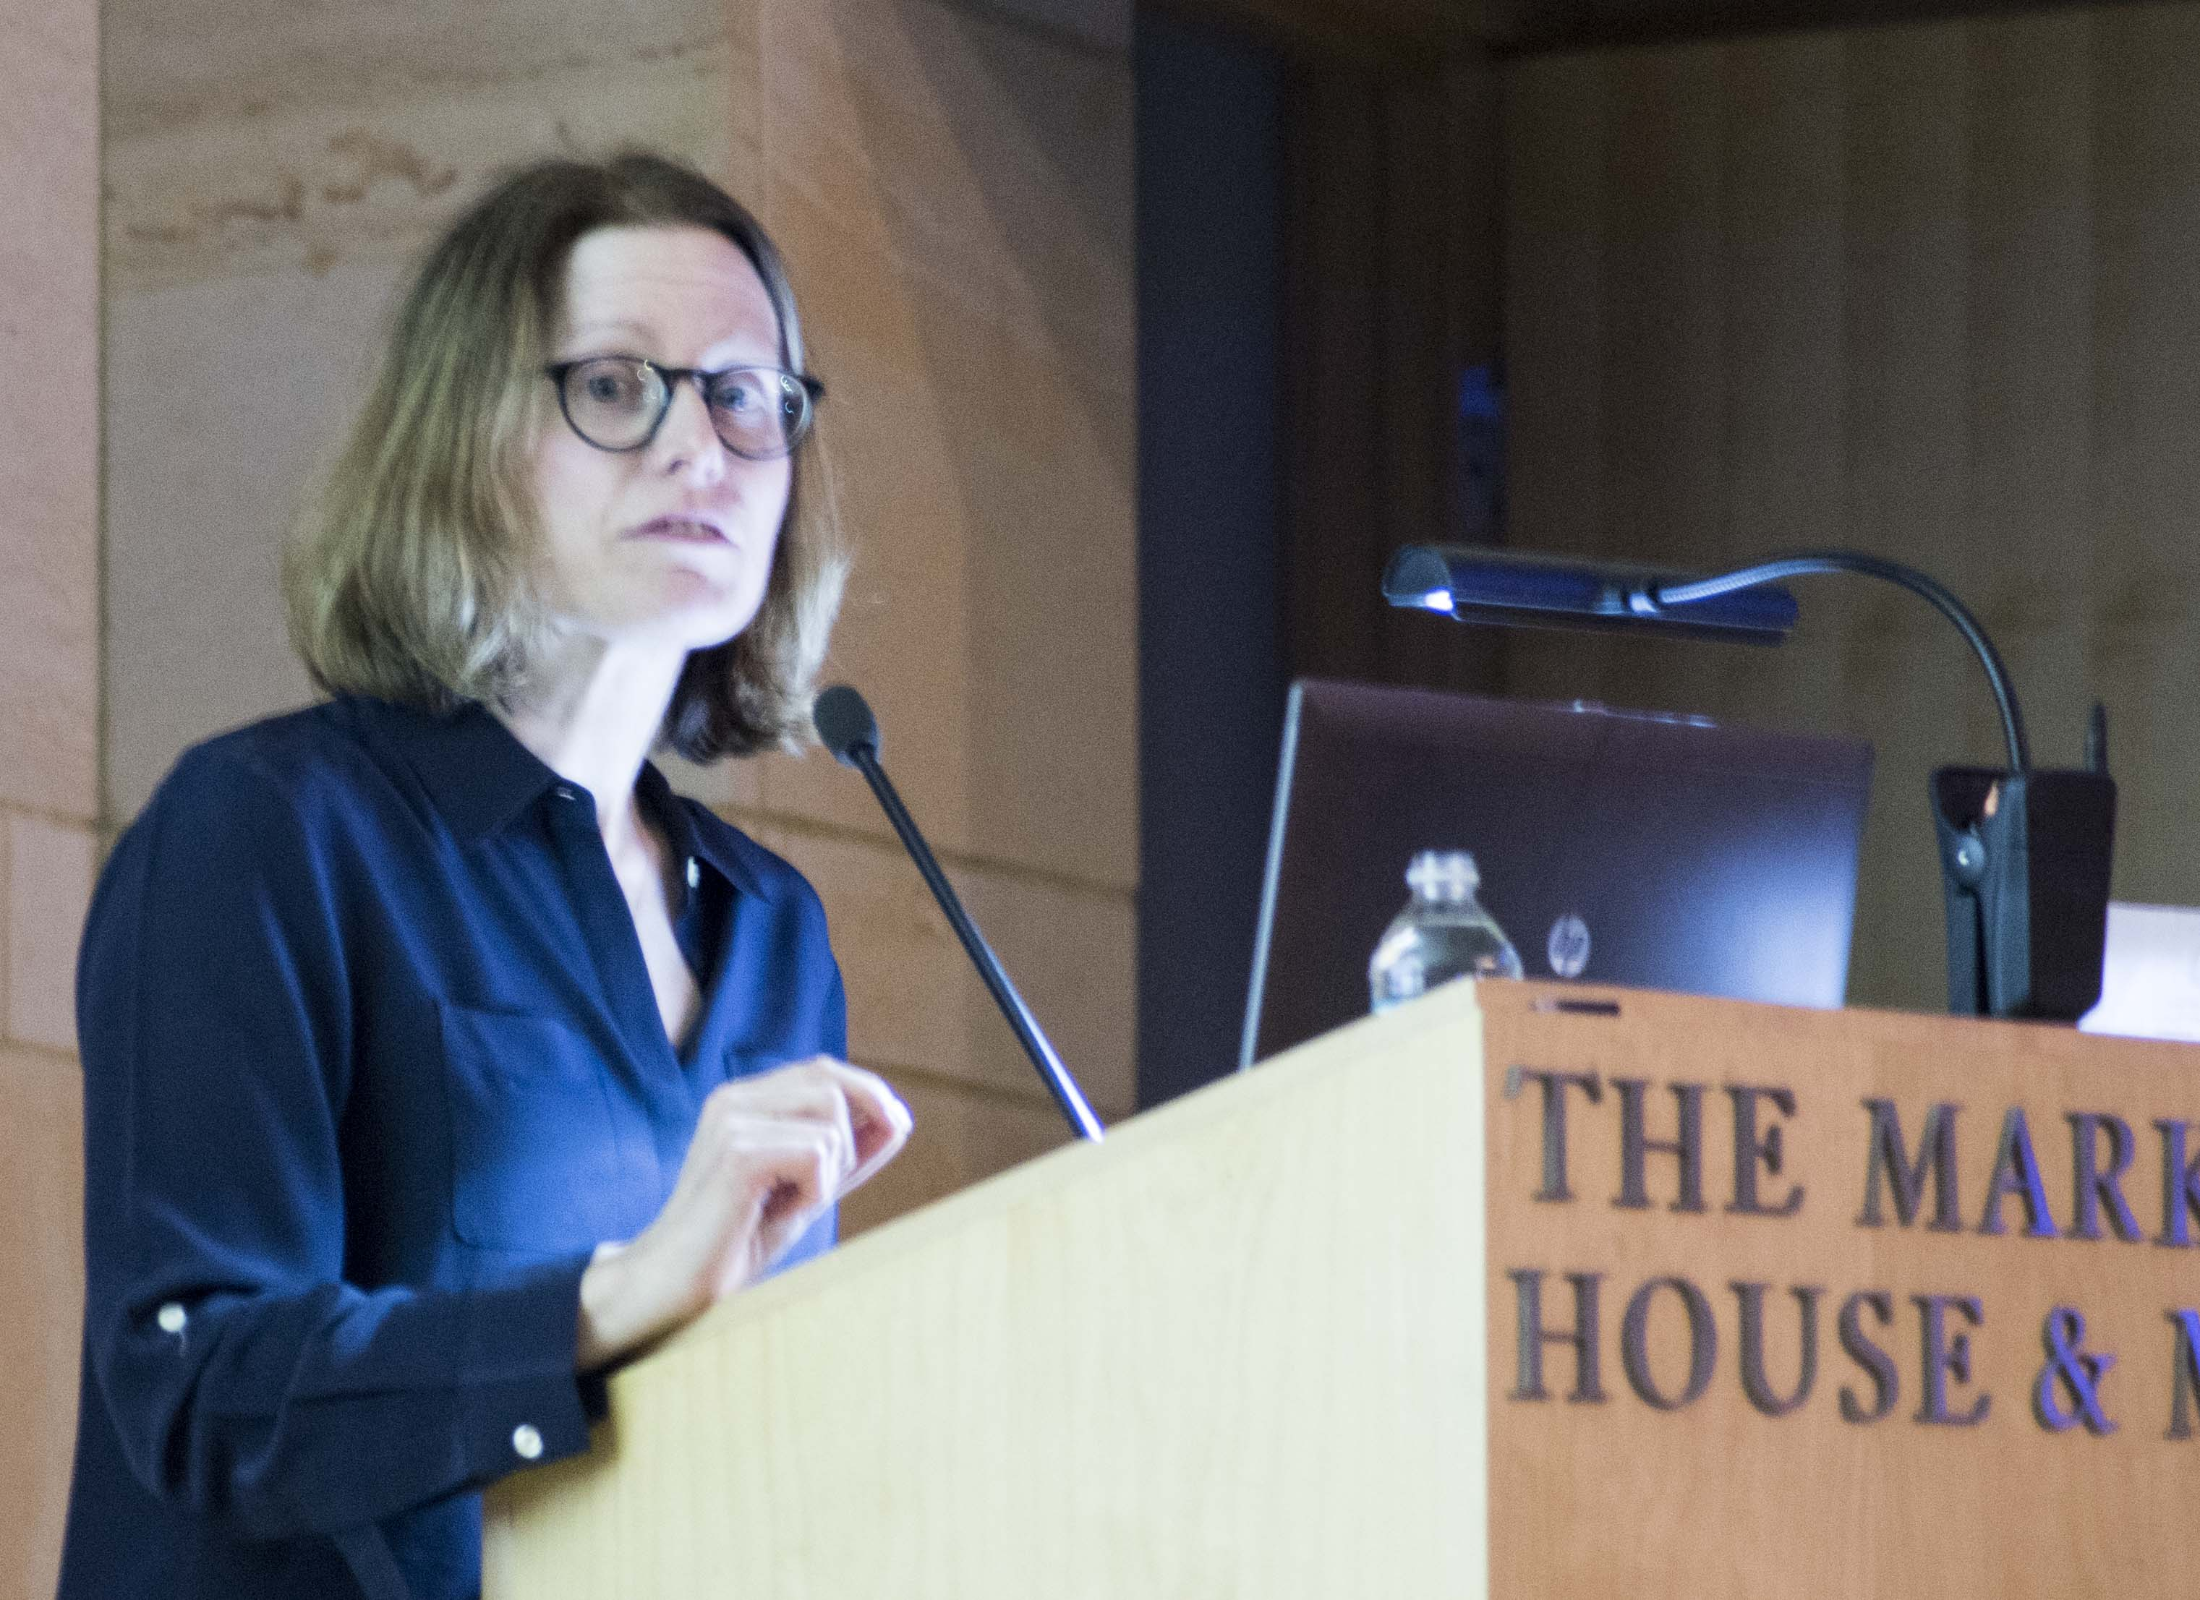
Back in May of last year, I attended the Harriet Beecher Stowe Center Annual meeting, which for some reason, I received an invitation. It was most remarkable in that it was the last Annual meeting under the direction of Katherine Kane as Executive Director and the first appearance of Briann Goldfield, which I wrote about in the following News & Views.
In January I received an invitation to the Mark Twain House & Museum Annual meeting, but the first notice of it came from the Stowe Center newsletter saying that Briann would be the guest speaker.
I was happy to be there, both because It’s nice to see how other non-profit organizations conduct their annual meetings, but more importantly what our neighbors have to say to one another.
Briann began her remarks by honoring the Twain & Stowe houses common founder and by that, she meant Catherine Seymour Day. Each of the museums focus most of their attention on the works and lives of their famous writers, but it’s very important to remember that it was Catherine Seymour Day, Harriet’s Great –niece, who saved the Twain House from demolition and began the museum before doing the same for the Stowe House and the Day House next door.
Briann continued with a slideshow of photos first of Harriet’s husband Calvin in a rocking chair on Twain’s porch showing the neighborly relations of these two families. She goes on to speak of the importance of history and its stories in our lives today. While Uncle Tom that was so celebrated then by mostly the white middle class, today the name is considered a racial slur. Stowe herself, who portrays the white child Little Eva as saving Tom, was not free of racism.
“To celebrate Stowe without recognizing her own racism… locks us into a racist ideology that it’s time for us to overcome. We must transcend it, and we transcend it when we understand it.” Briann says.
Her presentation goes on to show several items from the Stowe collection that are very foreign to us now including a cameo of Harriet that was presented to her by abolitionist women in England set in braided human hair.
She concludes by pointing out that these historic items serve to pique our curiosity and encourage us to learn. “And concludes, “the fundamental values that will build us a better society are just that, curiosity and a willingness to learn…”
After her talk, Pieter gave out the traditional “Sammie” awards (Mark Twain bobble heads) to Alstate, the Richard P. Garmany Fund. Volunteers of the Year included Cindy Curry, Sue Israel, Rebecca Nisely, and Gail and Ed Thibodeau for their contributions in restoring two gardens, including the Fran Gordon Memorial Garden.
Photos are at: https://photos.app.goo.gl/jqwjuq5PvWU6ZXVk6

