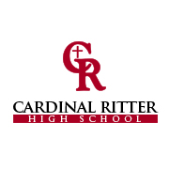
2018 Cardinal Ritter High School
West Deanery Night

Calling all future volleyball stars:
Our Lady Raiders invite you to watch them battle archrival Speedway. Hangout with the Cardinal Ritter volleyball team and eat with them before the game! We will raffle off CRHS Volleyball gear and you will get to meet our Head Coach, Ms. Catie Triplet. Join us for food, fun, and exciting volleyball action for FREE!

- When: Monday, Sept. 17th
- Where: Cardinal Ritter High School Cafeteria
- Time: 5:00 p.m. (Pizza and drinks provided)

