2018 CELEBRATION OF Excellence

Awards Gala
  - Sponsorship Package

Overview

The Drumheller and District Chamber of Commerce, Drumheller Rotary Club and Town of Drumheller are pleased to announce an exciting partnership. The three organizations will be joining forces on Friday, June 15, 2018 to jointly host the Celebration of Excellence Awards Gala at the Badlands Community Facility. The celebration will honor individuals and businesses for their achievements and contributions to the community. Together the group will present a total of twelve awards, including Citizen of the Year, Business of the Year and Youth Leader of Tomorrow. The semi-formal gala will feature cocktails and dinner with musical entertainment followed by the awards presentation emceed by Jason Blanke.

This is a highly-anticipated event for the community, with an expected attendance of 200-400 people. Our event committee invites you and your business to participate in the Celebration of Excellence through one of the sponsorship opportunities available.

Gold Sponsor- $1,250 + GST
Only 2 available. Includes:

- 4 tickets to the Gala
- 10-15 minute speaking opportunity
- Logo placement on the event program and slideshow
- Logo placement in print, electronic and verbal advertising for the event
- Opportunity to display banners, promotional materials, etc.
- 1 seat on the Chamber Business Awards Selection Committee

Silver Sponsor- $750 + GST
Includes:

- 2 tickets to the Gala
- Logo placement on the event program and slideshow
- Logo placement in print, electronic and verbal advertising for the event
- Opportunity to display banners, promotional materials, etc.
- 1 seat on the Chamber Business Awards Selection Committee

Bronze Sponsor- $500 + GST
Includes:

- 1 ticket to the Gala
- Logo placement on event program and slideshow
- Recognition in electronic and verbal advertising for the event
- Opportunity to display banners, promotional materials, etc.

Entertainment Sponsor- $500 + GST
1 available. Includes:

- 1 ticket to the Gala
- Recognition on stage as entertainment sponsor for the event
- Logo placement on event program and slideshow

Table Sponsor- $50 + GST and centerpiece
This is your opportunity to showcase your business in a creative way, at an event that will attract between 200-400 attendees. Design a table centerpiece that symbolizes or showcases what your business has to offer. Please see examples of table sponsor centerpieces on the next page.

Additional Event Information:
- Tickets to the Gala are $40 each, including gst
- Full tables can be purchased for $320 (8 tickets)
- Tickets include buffet dinner, music, and great company!
- The event takes place Friday, June 15th, at the Badlands Community Facility
- Cocktails are from 5:00 pm – 6:00 pm, with the awards and dinner to follow.
- Expected attendance is 200-400

If you are interested in any of these sponsorship opportunities or have questions about the event, feel free to contact me at your convenience by email at m.henneigh@drumhellerchamber.com or by phone at 403-823-8100.
Thank you for your consideration.
Marley Henneigh
Office and Chamber Services Coordinator
Drumheller and District Chamber of Commerce

Table Sponsors- Centerpiece Examples
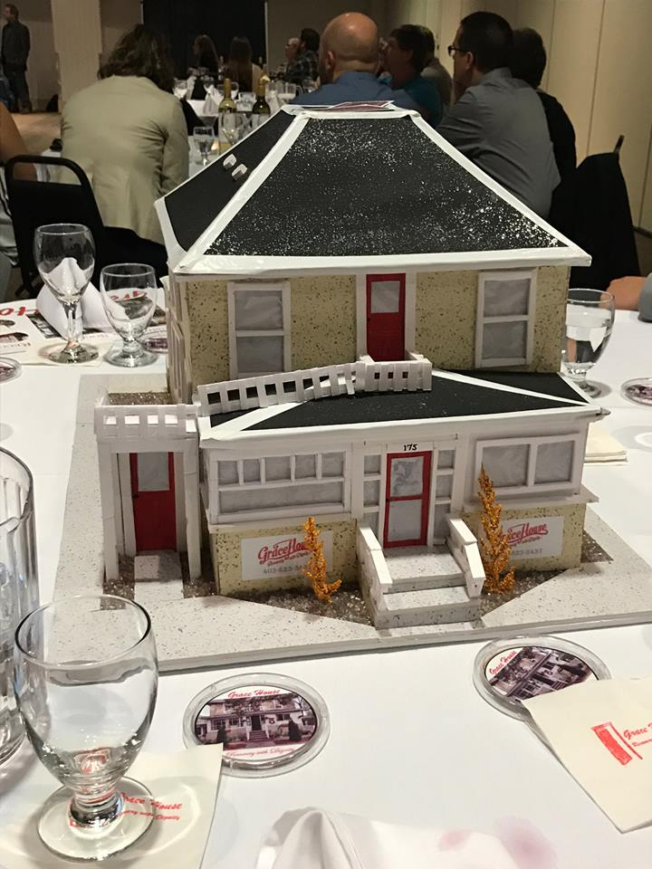  The Grace House centerpiece- 2017 Awards Gala | 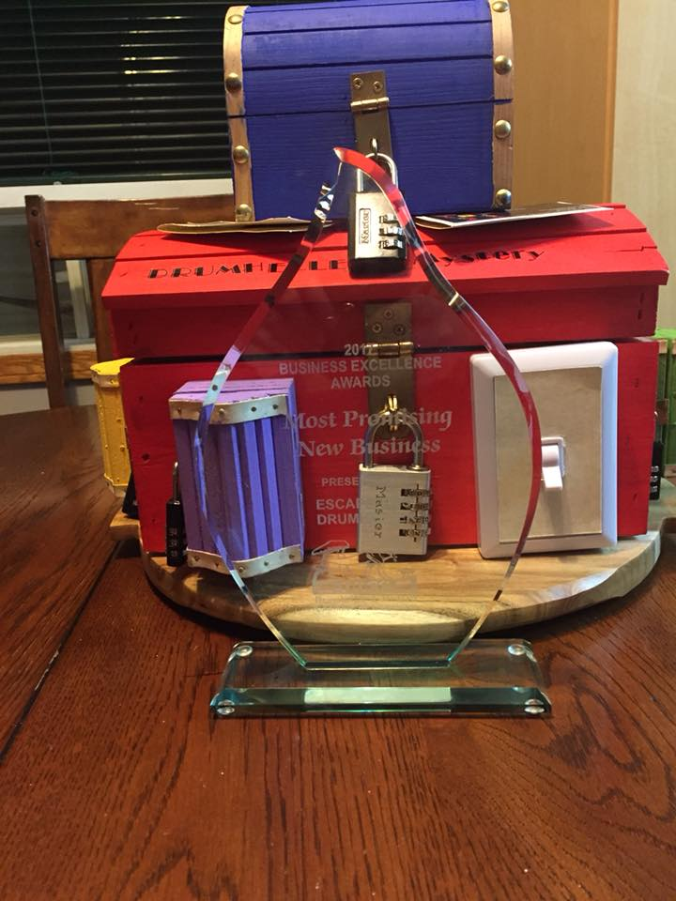  Escape This!- Escape game centerpiece
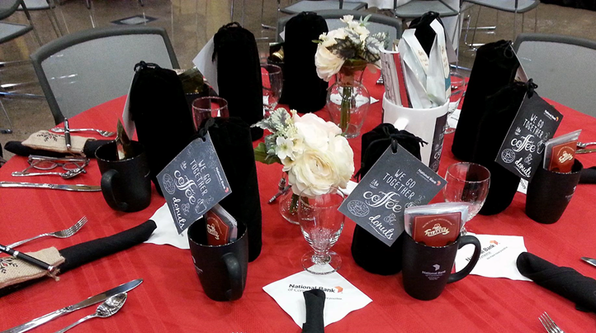  Example from a bank | 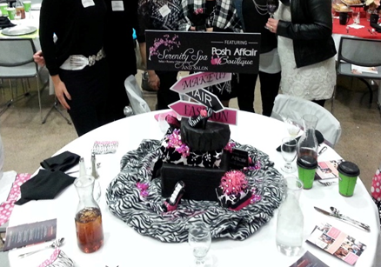  Example from a Spa
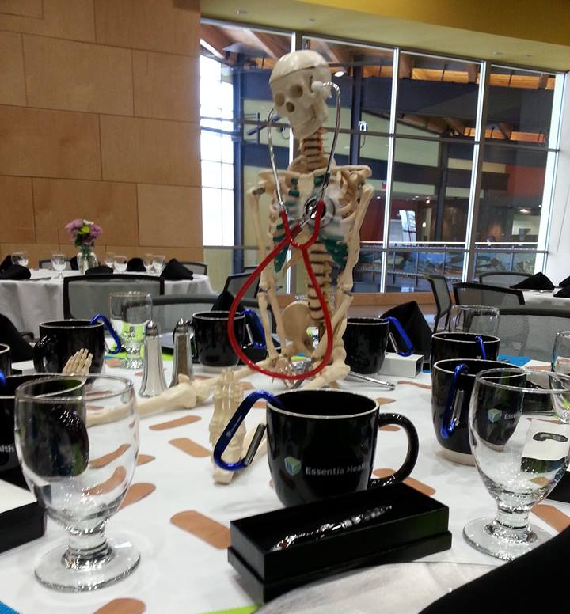  Example- from a medical clinic | 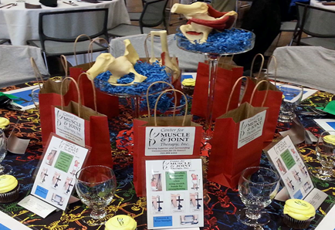  Example- from a Chiropractor

