40th Annual State
Virtual Institute! Celebrating 40 years of Revenue Cycle excellence

When:
Thursday December 2nd noon-5:00pm
and Friday December 3rd noon -4:30 pm

Meeting Cost:
$75.00 and $50.00 for Each Additional Attendee You
Register With Your Registration

EARLY BIRD REGISTRATION!!!! The first
50 to register by November 5th, 2021 will receive an IL AAHAM gift delivered to the address you register under. Please do
not open until our celebration on
December 2nd at 4:00

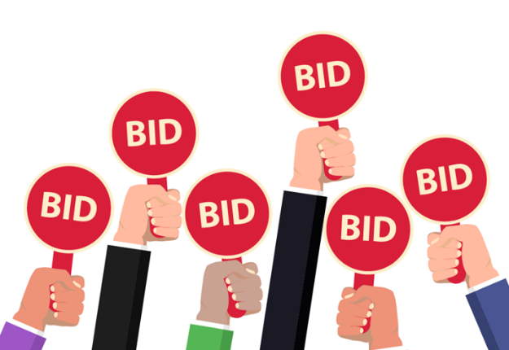

SILENT AUCTION BENEFITING OUR FRONTLINE WORKERS!!!

Back by Popular Demand, Charity Auction…Virtually!
Bid on donated items and all proceeds will go to
Mental Health Advocacy for Healthcare Workers, First Responders First.

The ability to heal is at the center of any health condition and every health crisis.
This is a human truth.
The people at the center of public health are our first responders:
our frontline workers, healthcare professionals, social workers and caregivers.
In order to do their job of caring for others, they must be well-supported with resources that lift them up and strengthen their resilience, mentally and physically.
As frontline workers continue to serve amidst the ongoing public health crisis of COVID-19, they must adapt and respond to the ever-evolving challenges facing our communities. #FirstRespondersFirst takes a whole human approach to addressing the needs of our frontline workers in order to support their ability to serve. Donations provide essential supplies, equipment, accommodations, child care, food, and critical mental health support and resources to ensure that our frontline workforce is protected, well-supported and resilient.

*******************************************************
Thursday December 2, 2021
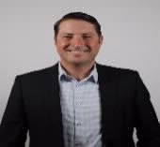
12:15pm-1:15pm
Tyler Enslin International
Remaining Positive in Times of Crisis

DESCRIPTION
Beginning in March of 2020 the word “crisis” took on new meaning for billions of people. For most a global pandemic meant unprecedented challenges in relation to their careers, personal life, finances, relationships, and even physical and mental health. These issues were magnified when restrictions that were expected to last for a few weeks lingered on for over a year. This highly interactive program has been specifically designed to help participants to navigate these unique challenges as well as to reflect on personal lessons learned from the experience. Thus the content has been customized to impact both career and personal aspects of life. Attendees will learn strategies that can help them to control stress levels, build habits to promote growth, and focus on opportunities. As the world collectively works towards a return to “normal,” we know that even during relatively good times, stress, challenges, and crises are often a part of life. Therefore although this training is framed through the lens of a global pandemic, we have carefully designed the content to be applicable to virtually any crisis that participants may face in the future.

LEARNING OBJECTIVES
Discover 3 keys to manage mindset and reduce stress
Create positive habits to promote personal growth
Learn specific techniques to stay focused and productive during challenging times
Create individual action items to maximize opportunities
ABOUT TYLER
As a professional speaker since 2012, Tyler has had the privilege to present at over 1000 live events. A determined entrepreneur from day one, he started his first business at the age of 17. While growing a small business into a successful enterprise proved to be an exciting challenge, by 2011 he was ready for a new endeavor. Tyler sold his business and went to work as a salesperson for a national training company where he became immersed in the field of public speaking. Initially a source of fear and nervousness, Tyler ultimately grew to love both public speaking and the professional development industry. As a result he soon became the top sales person in the organization, and eventually went on to hold the positions of regional and national director. In January 2018, he returned to the world of business ownership and launched Tyler Enslin International where he focuses full time on providing engaging practical content to audiences around the world. Tyler has been privileged to speak for hundreds of different organizations and companies ranging from Fortune 500 to small local businesses. He has also
been a Talent Management Consultant for Johns Hopkins University since 2016 where he enjoys teaching a regular schedule of workshops to help promote the growth and development of their employees. Tyler views each event as a unique opportunity to help his participants and therefore he has a reputation for being relatable, engaging, and delivering a high level of practical value.

*******************************************************
Thursday December 2, 2021
1:15pm-1:30pm
Corporate Partner Networking Breakout Rooms

1:30pm-2:30pm
Provider Panel - Moderated by Marcus Morrow
Law Office of Stephenson, Acquisto & Colman
Participants include: Hospital Sisters Health System, Rochelle Community Hospital, Morris Hospital, Riverside Healthcare, OSF Healthcare and Warner Hospital

2:30pm-2:45pm
Break

2:45pm-3:00pm
Corporate Partner Networking Breakout Rooms

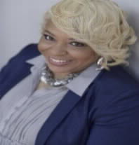
3:00pm-4:00pm
Robin R. Shabazz, Esq.
Principal Consultant, The Eastledge Group LLC
Managing Unconscious Bias using
Cultural Intelligence
DESCRIPTION
The workplace has changed. Daily intercultural interactions is the new normal. Demographics, migration, virtual work teams and economic changes have altered the social context of work. Today’s workers, across a broad range of accountability levels, job roles, organization size, and industry, in home markets and across borders, interact daily with individuals from backgrounds vastly different than their own. That reality requires a new workplace competency; the ability to manage multiple sources of cultural diversity at once. Cultural Intelligence (CQ) is the natural evolution from the now well-established notions of Intelligence Quotient (IQ) and Emotional Intelligence (EQ).
.

ABOUT ROBIN
Robin is a licensed attorney and mediator in the State of Ohio, whose career has spanned over 30 years with proven results in cultural transformation, diversity and inclusion, human resource management, and employee relations. As a certified Unconscious Bias and Cultural Intelligence facilitator, Robin capitalizes on her diverse background to bring both a pragmatic and risk mitigation approach to her work. Her clients range from state government agencies to nonprofits and global Fortune 50 companies.

*******************************************************
Thursday December 2, 2021

4:00pm-5:00pm
Anniversary Celebration
Join us for opening early bird registration gifts, learn your ‘Personality Color”, thank your outgoing and incoming Board of Directors, a special tribute and silent auction winners announced!
*******************************************************
Friday December 3, 2021
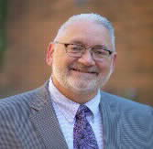
12:00pm-12:30pm
Richard (Rick) Rogers, CRCE, National Secretary
National AAHAM Updates

ABOUT RICK
Rick has been working in healthcare since his graduation from Marquette University in 1983. After spending 10 years in clinical medicine, Rick spent 7 years in healthcare IT and has been working in healthcare revenue cycle consulting and outsourcing since 1999.

In the past, Rick has led the Minnesota Gopher Chapter of AAHAM as President and Chairman. As Chapter President, Rick was tasked with working on the Government Relations Committee which he chaired following his tenure as the Chapter President. Rick currently serves as AAHAM National Secretary. He is an active member of the dynamic and growing Illinois AAHAM Chapter and looks forward to his continued involvement with this chapter, being a model for other chapters.

*******************************************************
Friday December 3, 2021
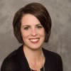
12:30pm-1:30pm
Nicole Querio, Director of Customer Experience
efficientC & OS inc.
Engaging All of Your Revenue Cycle in Denial Prevention
DESCRIPTION
There are many departments involved in a hospital’s revenue cycle. Why do we always lay the responsibility of denial prevention at the feet of the hospital business office? In this presentation, Lori Zindl will give an overview of the revenue cycle and show how every department involved has an important role to prevent denials. Using a color-coded UB form, Lori will demonstrate the impact each functional area of the revenue cycle can have on improving a hospital’s first pass payment rate.

ABOUT NICOLE
Nicole Querio is Director of Customer Experience at efficientC. Nicole joined the efficientC team in 2020 from Sauk Prairie Healthcare where she was Revenue Cycle Director. Nicole has over 15 years of experience managing the revenue cycle, in both clinic and hospital settings. Nicole is a graduate of UW-Green Bay holding a degree in Psychology and Human Development. In 2014, she achieved the Certified Revenue Cycle Executive certification through AAHAM, and also completed coursework through the Sauk County Institute of Leadership. She is currently enrolled at Lakeland University pursuing her MBA. Nicole is passionate about the revenue cycle, continuous improvement, and data analytics working directly with efficientC customers to help them get 95% of their claims paid in 20 days or less.

1:30pm-1:45pm
Corporate Partner Networking Breakout Rooms

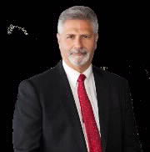
1:45pm-2:45pm
Richard A Lovich, Esq.
Co-Managing Partner, SAC
Legislative Updates!
ABOUT RICH
Mr. Lovich is SAC’s Co-Managing Partner with 35 years of litigation experience as senior trial counsel on litigated and arbitrated cases involving healthcare providers seeking proper and full reimbursement from network health plans, self-funded ERISA plans and governmental entities. In 2014, Mr. Lovich was named national legal counsel for AAHAM. In May 2016, Mr. Lovich was invited to testify on behalf of AAHAM before the United States Senate Commerce Committee on the impact of the TCPA on the healthcare industry. In 2020, Mr. Lovich on behalf of AAHAM was appointed to serve on the FCC Hospital Robocall Protection Group, providing best practices for telecommunications providers to protect hospitals from unwanted and illegal robocalls that disrupt patient care.

*******************************************************
Friday December 3, 2021
2:45pm-3:00pm
Break

3:00pm-3:15pm
Corporate Partner Networking Breakout Rooms
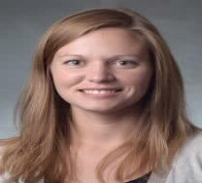
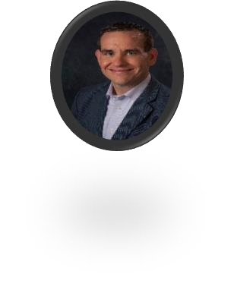

3:15pm-4:15pm
Cassie Yarbrough, Senior Director and Lance Kovacs, Director
IHA Legislative and Regulatory Updates

DECRIPTION
This presentation will cover significant issues that have impacted the hospital community at the federal, state, and local level over the past year including COVID-19 response, Provider Relief Fund, No Surprises Act, Hospital Price Transparency, a state public option, health equity, maternal health, and other key hospital regulatory changes.

ABOUT CASSIE
Cassie Yarbrough, Senior Director, Medicare Policy has been with the Illinois Health and Hospital Association (IHA) for two years. Cassie is responsible for analyzing and communicating federal healthcare policies, including Medicare payment rules, and how they impact hospitals and health systems across Illinois. Prior to joining IHA, Cassie worked for the American Dental Association (ADA), where her work focused on access to and utilization of dental services under private payers and Medicaid, with recent research focused on the economic and societal impact of expanding dental coverage to traditional Medicare.

ABOUT LANCE
Lance Kovacs, Director of Health Policy and Regulatory serves as the Illinois Health and Hospital Association’s lead on key regulatory issues impacting hospitals. He covers a wide array of policy issues including: Certificate of Need, the Hospital Licensing Act, Perinatal and Maternal levels of Care, supplier diversity, health care professional licensure, and as the hospital community’s lead responding to public option proposals. Lance has been at IHA for over 5 years and has nearly 15 years of experience in regulatory and government relations roles for various medical professional associations and the State of Illinois.

Adjourn
13 AAHAM CEUs are available for this conference

