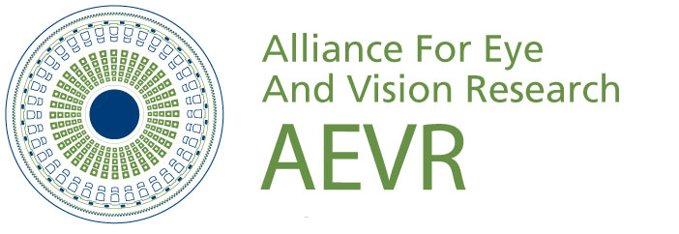

THE ALLIANCE FOR EYE AND VISION RESEARCH
With Sponsor RESEARCH TO PREVENT BLINDNESS

Invites you to an Evening Reception Featuring Research Posters

by Early-Stage Vision Investigators

Fifth Annual Emerging Vision

Scientists Reception

Wednesday, September 18, 2019

5:30 – 7:30 pm

House Rayburn Foyer

- Meet New AEVR President Paul Lee, MD, JD (Kellogg Eye Center at the University of Michigan), who will host the event.

- Speak with 21 Emerging Vision Scientists from across the nation displaying posters about research to save sight and restore vision.

- Learn how research can delay, reduce, and prevent the $717 billion annual cost of eye disease/vision impairment projected by year 2050.

R.S.V.P. to
Dina Beaumont @ 202-407-8325 or dinabeau@aol.com

AEVR, a 501(c)3 Non-Profit Educational Foundation, is pleased to host this widely attended event supported by a grant from Research to Prevent Blindness and held during Healthy Aging Month and International Age-Related Macular Degeneration (AMD) Awareness Week.

Scientist | Institution | State | Area of Expertise
Ava Bittner, OD, PhD | UCLA/Stein Eye | CA | Low Vision Rehabilitation
An-Jey Su, PhD | University of Colorado | CO | Whole Eye Transplantation
Florence Cabot, MD | U. Miami/Bascom Palmer | FL | Tele-Ophthalmology
Jessica Steen, OD | NOVA Southestern College of Optometry | FL | Retinal vasculature in cystic fibrosis patients
Ian Han, MD | University of Iowa | IA | Gene Therapy for retinal diseases; Photoreceptor cell replacement
Stephanie Adams, OD, PhD | Illinois College of Optometry | IL | Diagnosing Alzheimer’s through the eye
Mallika Valapala, PhD | Indiana University School of Optometry | IN | AMD
Jesson Martin, PhD | Kentucky College of Optometry | KY | Myopia Control in Children
Kinga Bujakowska, PhD | Mass Eye & Ear/Harvard Medical School | MA | Inherited Retinal Degenerations
Vicki Chen, MD | Tufts Medical Center | MA | Epidermolysis bullosa
Sangeetha Metlapally, PhD | New England College of Optometry | MA | Image quality, 3-D vision
Jia Yin, MD, PhD | Mass Eye & Ear/Harvard Medical School | MA | Corneal angiogenesis, wound healing and immunology
Abigail Fahim, MD, PhD | University of Michigan | MI | Transport and release of proteins of the retinal pigment epithelium
Lynn Hassman, MD, PhD | Washington University | MO | Uveitis
Muneeb Faiq, PhD | NYU/Langone | NY | Glaucoma, role of insulin
Ajay Kuriyan, MD | Flaum Eye/U of Rochester | NY | Proliferative vitreoretinopathy
Sumit Sharma, MD | Cleveland Clinic/Cole Eye | OH | Uveitis
Susana da Silva, PhD | University of Pittsburgh | PA | Fovea Development
Irina De La Huerta, MD, PhD | Vanderbilt | TN | Diabetic Retinopathy
Daniel Coates, PhD | University of Houston College of Optometry | TX | Central Vision Loss and Reading
Ross Collery, PhD | Medical College of Wisconsin | WI | Refractive Error and Retinal Degeneration

